Atypical functional connectome hierarchy in congenitally blind humans

Cemal Koba1*, Joan Falcó-Roget1, Olivier Collignon, Katarzyna Rączy, Marina Bedny, Mengyu Tian, Marcin Szwed, Anna-Lena Stroh2*

Keywords: brain plasticity; development; gradients; vision; hierarchy

1 Computer Vision Team, Sano Centre for Computational Medicine, Krakow, Poland

2 Institute of Psychology, Jagiellonian University, Kraków, Poland

**Author contributions**

**Cemal Koba:** Conceptualization, Methodology, Software, Formal analysis, Data curation, Writing - Original Draft, Writing - Review & Editing, Visualization, **Joan Falco Roget:** Methodology, Writing - Review & Editing, **Olivier Collignon:** Resources, Writing - Review & Editing, Funding Acquisition, **Katarzyna Raczy:** Investigation, Data curation, Writing - Review & Editing, **Marina Bedny:** Resources, Writing - Review & Editing, Funding Acquisition, **Mengyu Tian:** Writing - Review & Editing, **Marcin Szwed:** Resources, Writing - Review & Editing, Funding Acquisition, **Anna-Lena Stroh:** Conceptualization, Methodology, Software, Formal analysis, Data curation, Writing - Original Draft, Writing - Review & Editing, Visualization

Abstract

The cortex is organized along macroscale gradients that extend from unimodal to transmodal association areas and from somatosensory to visual regions. Whether this core organizational axis represents an intrinsic neuro-architecture immune to sensory experience or depends on sensory input has not been tested. To address this question, we conducted connectome gradient analyses using resting-state functional Magnetic Resonance Imaging in congenitally blind (n = 41) individuals and sighted controls (n = 44). In both groups, we observed a principal gradient (G1) extending from unimodal to transmodal areas, a second gradient (G2) spanning from somatosensory to visual regions, and a third gradient (G3) separating the frontoparietal network from the rest of the brain. These findings indicate that the macroscale organization of the cortex develops largely independently of sensory experience. However, in blind individuals, G1 was contracted between visual and transmodal areas, G2 was expanded between somatosensory/motor and visual regions, and G3 was contracted between visual regions and the frontoparietal network. The hierarchical organization within the early visual cortex was altered, and structure-function coupling was reduced in visual and temporal areas of blind individuals. These results underscore the critical role of sensory input in shaping the macroscale functional and structural organization of the brain.

1 - Introduction

The cortex is organized along macroscale functional and structural gradients that extend from unimodal (somatosensory/motor and visual) to transmodal association areas, and from somatosensory to visual areas [1,2](https://www.zotero.org/google-docs/?vl9vB5). This organization is hypothesized to be essential for the emergence of abstract, higher-order cognitive functions in transmodal, integrative cortices by isolating them from the processing of incoming environmental information [2](https://www.zotero.org/google-docs/?woP80e). Whether this core organizing axis is an intrinsic organizational neuro-architecture immune to experience or, instead, depends on sensory input during development has not been tested. To address this question, we compared functional connectivity gradients and their relationship to structural measurements between blind and sighted individuals.

Numerous studies have shown that blindness results in significant differences in the functional and structural organization of the brain. For example, there is ample evidence to suggest that the visual cortex of blind individuals can adapt to process auditory and tactile input [3](https://www.zotero.org/google-docs/?1XA43S), demonstrating that the sensory modality of a region is not fixed and can be changed by experience. Crucially, in blind individuals, visual cortices, including V1, do not only respond to low-level tactile and auditory stimulation, but also seem to be involved in higher-level functions, such as language [4,5](https://www.zotero.org/google-docs/?lt1R4u), numerical cognition [6](https://www.zotero.org/google-docs/?n6DJDF), and executive functioning [7,8](https://www.zotero.org/google-docs/?YOlgI3). Moreover, several studies have reported changes in resting state functional connectivity (rsFC), including a decrease of rsFC between visual and sensorimotor areas [4,9](https://www.zotero.org/google-docs/?is9y2q) and an increase between the visual cortex and the lateral prefrontal, parietal, and temporal cortices [4,7,10–13](https://www.zotero.org/google-docs/?pe96we). In addition to these functional changes, several structural changes have been observed in blind individuals, including increased cortical thickness [14–17](https://www.zotero.org/google-docs/?lvOkVj) and a reduction of the surface area of V1 [15,18](https://www.zotero.org/google-docs/?Jvgzns). Taken together, these findings could reflect alterations of the cortical hierarchy in blind individuals.

So far, neuroimaging studies in blind humans have not been able to successfully probe the hierarchical organization within the visual system and across the broader cortex. However, new developments in the analysis of resting-state functional magnetic resonance imaging (rs-fMRI) data now make it feasible to study functional hierarchies non-invasively. Recent studies that have used non-linear connectome compression techniques have revealed three principal gradients of connectivity differentiation along the cortical surface [1](https://www.zotero.org/google-docs/?YcFSbS). The principal gradient extends from unimodal to transmodal areas and closely corresponds to classic models of the cortical hierarchy [2,19](https://www.zotero.org/google-docs/?7QWjCM), thus making it ideally suited to investigate the effects of sensory experience on the development of the cortical hierarchy. The second gradient spans between the visual and sensorimotor systems [1](https://www.zotero.org/google-docs/?vu2wUE), differentiating regions depending on their involvement in modality-specific processing. The third gradient extends between areas of the brain that are typically involved in attentional modulation (fronto-parietal attention and control networks) and those that are involved in content representation (default mode, sensorimotor and visual networks)[20,21](https://www.zotero.org/google-docs/?1eS9TI). Together, the three gradients describe a functional organization in which primary sensory and transmodal regions exhibit functional segregation, while the salience network exhibits functional integration [22–24](https://www.zotero.org/google-docs/?H30KIu).

The structural organization of the human cortex seems to follow similar macroscale gradients as the functional organization. For example, MRI-based measures of cortical morphology and microstructure [25–27](https://www.zotero.org/google-docs/?C4yZYt), as well as structural connectivity [28](https://www.zotero.org/google-docs/?RXT6on) look strikingly similar to the principal gradient of functional connectivity. Thus, spatial trends in structural and functional organization seem to converge, suggesting that gradients may serve as an ideal framework for exploring structure-function relationships [29](https://www.zotero.org/google-docs/?mzQKHi). In fact, structure-function relationships also seem to be organized along a macroscale gradient. A tight coupling between structure and function has been observed within primary sensory and motor areas, whereas in transmodal association areas, structure and function seem to diverge [30–33](https://www.zotero.org/google-docs/?ZFPjzf). Although numerous studies have investigated both structural and functional plasticity in blind individuals, the coupling between the two remains largely underexplored. However, examining these relationships could provide valuable insights into how cortical structure adapts to support the higher-level functions associated with the visual cortices of blind individuals.

Gradients are valuable not only for studying the relationships between different cortical networks but also for examining functional organization *within* networks. By applying spectral embedding to voxel-wise connectivity, the functional organization of a network can be mapped using resting-state fMRI data [34](https://www.zotero.org/google-docs/?JEPR6U). Previous studies have used this approach to study the hierarchical organization within multiple brain regions, such as the primary somatosensory cortex [35](https://www.zotero.org/google-docs/?ZBt3Vm), the angular gyrus [36](https://www.zotero.org/google-docs/?jbZBSZ), and the insula [37,38](https://www.zotero.org/google-docs/?9ADgmD). These studies have revealed several gradients that have shown a strong correspondence with canonical functional networks and corresponding behavioral domains [36–39](https://www.zotero.org/google-docs/?OQL9S4), geometric distance [39](https://www.zotero.org/google-docs/?IgquJT), cortical morphology [39](https://www.zotero.org/google-docs/?8zsPB4) and microstructure [35](https://www.zotero.org/google-docs/?TuehvC), as well as gene expression [36](https://www.zotero.org/google-docs/?ffy1Xp). Moreover, previous studies have used rsFC gradients for cortical area parcellations and it has been shown that they exhibit strong correspondence with task activation maps and that they show a close correspondence with probabilistic V1 and V2 [40,41](https://www.zotero.org/google-docs/?Uacs8x). Together, these findings underscore the value of studying gradients within regions or networks to better understand hierarchical brain organization within and between functional networks. Here, we want to use this approach to investigate the functional hierarchical organization within the visual cortex, including early, ventral, dorsal, and lateral visual areas.

Here, we aimed to assess to what extent the core organizing axis of the human cortex depends on sensory input during development. To this end, we compared macroscale functional connectivity gradients between congenitally blind and sighted individuals. In addition, we aimed to investigate how the functional organization *within* the visual system depends on sensory input during development by comparing connectopic maps of the visual system between blind and sighted individuals. Finally, we aimed to examine how the structure of the (visual) cortex changes, in order to accommodate the new higher-level functions that have been associated with the visual cortices of blind individuals. To this end, we compared structure-function coupling between the functional connectivity gradients and a principal component derived from structural features including cortical thickness, curvature, sulcal depth, surface area, and volume.

2 - Methods

## 2.1 Datasets

**2.1.1 Dataset 1**

Complete details of the dataset and imaging parameters are given in Pelland et al. [42](https://www.zotero.org/google-docs/?WUXKoG). The entire dataset includes 50 participants who participated in a single five-minute functional MRI run (136 volumes). Participants were instructed to keep their eyes closed, relax, and not think about anything in particular. Functional time series were acquired using a 3-T TRIO TIM (Siemens) equipped with a 12-channel head coil. Multislice T2*- weighted fMRI images were obtained with a gradient echo-planar sequence using axial slice orientation; repetition time (TR) 2200 ms; echo time (TE) 30 ms; functional anisotropy (FA) 90 degrees; 35 transverse slices; 3.2 mm slice thickness; 0.8 mm gap; field of view (FoV) 192 X 192 mm2; matrix size 64 x 64 x 35; voxel size 3 x 3 x 3.2 mm3 . A structural T1-weighted 3D magnetization prepared rapid gradient echo sequence (voxel size 1 x 1 x 1.2 mm3; matrix size 240 x 256 ; TR 2300 ms; TE 2.91 ms; TI 900 ms; FoV 256; 160 slices) was also acquired for all participants. All of the procedures were approved by the Research Ethic and Scientific Boards of the Centre for Interdisciplinary Research in Rehabilitation of Greater Montreal and the Quebec Bio-Imaging Network. Experiments were undertaken with the understanding and written consent of each participant.

The study involved 50 participants, comprising 14 CB individuals (9 males, 5 females, mean age 43.93 ± 11.19 years, 12 right-handed, 2 ambidextrous), and 14 sighted control group that is age and sex-matched with CB sample (SC, mean age 40.92±13.64 years, 7 males, 7 females, 13 right-handed, 1 left-handed). The dataset was made available in the Brain Imaging Data Structure (BIDS, [43](https://www.zotero.org/google-docs/?QpuS2W)) format. Along with the folder and naming standardization, the first four volumes of functional runs were removed to avoid stabilization artifacts (leaving 132 volumes in total), and the resolution of the functional runs was interpolated to 3 x 3 x 4 mm3. The data providers confirmed that no other preprocessing steps were applied during the standardization procedure.

**2.1.2 Dataset 2**

The dataset was downloaded from Bedny and Tian [44](https://www.zotero.org/google-docs/?AMn8OH), and full details are available at Tian et al. [45](https://www.zotero.org/google-docs/?ebeddy). MRI anatomical and functional images were collected on a 3T Phillips scanner at the F. M. Kirby Research Center. T1-weighted anatomical images were collected using a magnetization-prepared rapid gradient-echo (MP-RAGE) in 150 axial slices with 1 mm isotropic voxels. Resting-state fMRI data were collected in 36 sequential ascending axial slices for 8 minutes. TR = 2 s, TE = 0.03 s, flip angle = 70°, voxel size = 2.4 × 2.4 × 2.5 mm, inter-slice gap = 0.5 mm, (FoV) = 192 x 172.8 x 107.5 . Participants completed 1 to 4 scans of 240 volumes each (average scan time = 710.4 seconds per person). During the resting state scan, participants were instructed to relax but remain awake. Sighted participants wore light-excluding blindfolds to equalize the light conditions across the groups during the scans.

50 sighted adults and 30 congenitally blind adults contributed the resting state data (sighted: n = 50; 30 females; mean age = 35.33 ± 14.65; mean years of education = 17.08 ± 3.1; blind: n = 30; 19 females; mean age = 44.23 ± 16.41; mean years of education = 17.08 ± 2.11. Blind and sighted participants had no known cognitive or neurological disabilities (screened through self-report). A board-certified radiologist read all adult anatomical images and no gross neurological abnormalities were found. All the blind participants had at most minimal light perception from birth. Blindness was caused by pathology anterior to the optic chiasm (i.e., not due to brain damage). All participants gave written informed consent under a protocol approved by the Institutional Review Board of Johns Hopkins University. The dataset was made online after normalizing anatomical and structural data to MNI space, changing the voxel resolution of T1 images to 2 mm3 and functional images to 2.4 x 2.4 x 3 mm.

**2.1.3 Dataset 3**

The dataset was collected in Malopolskie Centrum Biotechnologii, Jagiellonian University, Kraków on a 3T Siemens Magnetom scanner. T1-weighted anatomical images were collected using a magnetization-prepared rapid gradient-echo (MP-RAGE) in 1 x 1 x 1 mm voxels. Resting-state fMRI data were collected for 15 minutes. TR = 1.5 s, TE = 0.027 s, flip angle = 90°, voxel size = 3 x 3 x 3.5 mm . During the resting state scan, participants were instructed to relax but remain awake. The study was approved by the ethics committee of the Jagiellonian University. Written informed consent was obtained from all participants before the experiment. Participants were reimbursed for taking part in the study. The participants were screened and had no disability apart from vision loss. The dataset includes 17 congenital blind participants only (mean age: 25.75 ± 5.72, 6 females, 11 males), and is organized in BIDS format.

**2.1.4 Dataset curation and quality check**

Upon receiving, Dataset 2 was reorganized into BIDS format by a custom script. After an initial visual check, scans with artifacts were removed. Most common artifacts were blurriness due to motion and incomplete slices. At the end, out of 80 participants, 58 participants with single resting-state run (36 SC and 22 CB) were qualified for further processing. No participants were removed from Datasets 1 and 3 and their full samples (50 and 17, respectively) were used in the preprocessing steps.

## 2.2 Preprocessing

The datasets were preprocessed with Micapipe [46](https://www.zotero.org/google-docs/?N5iICh), an automatic processing pipeline using state-of-the-art software for processing structural and functional MRI data such as AFNI [47](https://www.zotero.org/google-docs/?f3ocGQ), FSL [48](https://www.zotero.org/google-docs/?TE0wFD), ANTs [49](https://www.zotero.org/google-docs/?yilB7S), FreeSurfer [50](https://www.zotero.org/google-docs/?09cgsh), FastSurfer [51](https://www.zotero.org/google-docs/?fI0d9E), and Connectome Workbench (RRID:SCR_008750). Full details of the analysis pipeline can be found at https://micapipe.readthedocs.io/. Briefly, each T1-weighted run was LPI-reoriented, deobliqued, and oriented to standard space (MNI152), a bias-field correction was applied, and the intensity of the images was rescaled between 0-100. Whole-brain, gray matter (GM), white matter (WM), and cerebrospinal fluid (CSF) segmentation was performed. The T1 image was then non-linearly registered to MNI152. Surface meshes in individual spaces were created. Affine registration from fsaverage5 mesh to individual meshes were calculated. Using these registration matrices, Glasser parcellation [52](https://www.zotero.org/google-docs/?OEq5t4), which is available in Micapipe library for fsaverage5 mesh, was sent to subject space. Using the 360 available regions of interest (ROI) in Glasser parcellation, regions-wise stats such as cortical thickness, mean curvature, surface area, sulcal depth, and cortical volume were calculated.

Functional images were reoriented to LPI orientation, and a motion-correction algorithm with 6 parameters (rigid-body) was applied to the time series. The motion-corrected time series were then projected to the fsnative5 mesh and smoothed with a 10 mm Gaussian kernel. Outputs of Micapipe were further cleaned from nuisance regressors using a custom script written in MATLAB. The 36P strategy without global signal regression that is described in Satterthwaite et al. [53](https://www.zotero.org/google-docs/?Y2RTWg) was adopted to choose the regressors of no interest. Specifically, 6 motion regressors, mean signal from white matter and CSF, their first derivatives, power, and power of the first derivatives were chosen. In addition, mean frame-wise displacement and a linear trend were added to the model. These regressors were removed from the fMRI data using a multiple linear regression model and the residuals were saved. A band-pass filter between 0.01-0.1 was applied to the residuals.

## 2.3 Calculating the functional connectivity gradients

For each participant, preprocessed time series on fsaverage5 mesh were parcellated using Glasser atlas (fsaverage5 version available in Micapipe library). The averaged time series were then correlated with each other, resulting in 360 x 360 correlation matrices for each participant. The matrices were normalized via Fisher’s Z transformation.

Functional connectivity gradients based on normalized correlation matrices were generated as described in Margulies et al. (2016) using the available functions in the BrainSpace MATLAB toolbox [54](https://www.zotero.org/google-docs/?vEUuJt). In short, correlation matrices were thresholded to keep the top 10% of the connections. Cosine similarity of the sparse matrices was calculated. A non-linear dimension reduction technique, diffusion mapping, was applied to the similarity matrices with an alpha value of 0.5 for the manifold. This step generated 10 gradient values that explain the functional connectivity profile of each ROI and for each participant. Lastly, Procrustes alignment was used on the gradients to make them comparable. Since diffusion mapping can result in values in the opposite directions, a reference gradient available in BrainStat library [55](https://www.zotero.org/google-docs/?4L5pjL) is used for alignment, which is calculated with the same parameters on fsaverage5 mesh. This procedure generated "gradient scores" that show the position of each region in the embedding space for 10 gradients.

To decrease noise, an inter-subject correlation matrix was calculated based on scores of the first gradient. Participants who showed a smaller Pearson’s r than the absolute value of 0.4 were removed from further analyses. The final sample for SC-CB comparison included 44 SC and 41 CB.

## 2.4 Statistical analyses

**2.4.1 Connectivity gradients across neocortex**

After removing the effect of age and sex from the gradient scores via a multiple linear regression model, the residuals were used to compare the differences across SC and CB groups for each ROI via a between-sample t-test. This comparison was repeated for 3 gradients. The results were corrected for multiple comparisons with the false-discovery rate (FDR) at p = 0.05. Following the region-wise comparison of the gradient scores, the gradient range (the maximum value minus the minimum value) was compared between groups using a multiple linear regression model where age and sex are included as regressors of no interest. The explanatory power of age on the gradient range was also reported. In addition, the explained variances of the gradients, and the variance of the gradient scores were compared across CB and SC groups with a between-sample t-test. Effects of age and sex on the gradient range, variance, and explained variance were accounted for using a linear regression before applying the t-test.

**2.4.2 Representation of the early visual areas in the embedding space**

To check if the functional organization in the embedding space reflects the hierarchy of the visual areas, and if this representation is different in the CB group, the position of the early visual areas across the first three gradients was checked in terms of their ranking and distance.

To calculate the rank, gradient scores of V1, V2, V3, and V4 regions (averaged over right and left hemispheres) were ordered from lowest to highest, and their ranking in this order (1 for the lowest value) was saved. A Wilcoxon rank sum test was used to check if there was a difference in the region’s ranking between groups.

To calculate the distance, the minimum gradient score difference between each early visual area (V1, V2, V3, V4) to any other early visual area was calculated. The distance in the gradient score was representative of the functional similarity. Therefore, the closer a region is to other regions, the higher functional similarity it represents. We used R [56](https://www.zotero.org/google-docs/?WaOa2w) and afex [57](https://www.zotero.org/google-docs/?KVxAOl) to perform a linear mixed effects analysis on the minimum distances. As fixed effects we entered group (CB individuals vs SC) and ROI (V1, V2, V3, V4), as well as their interaction terms into the model. As random effects, we had intercepts for participants. P-values for fixed effects were obtained with the Satterthwaite method and were considered significant at p < .05. Post-hoc comparisons of significant interactions were conducted using approximate z-tests on the estimated marginal means using the emmeans package [58](https://www.zotero.org/google-docs/?EtYTB7). The resulting p-values were corrected for multiple comparisons following the procedure proposed by Holm (1979). Preliminary analyses of minimum distances and visual inspection of q-q plots of the residuals indicated deviations from normality. Thus, minimum distances were log transformed (log(minimum distance)) which led to a roughly normal distribution of the residuals.

**2.4.3 Structure-function coupling**

For each participant, mean cortical thickness, curvature, sulcal depth, surface area, and volume of each 360 ROIs were extracted. To decrease the dimension of the data and account for all these structural measures at once, a principal component analysis (PCA) was applied to these 5 measures, and the first component was saved. This step created one structural component per participant.

Inter-subject correlation matrix on the structural component showed distinct similarity patterns across 3 datasets, indicating a strong effect of the scanning site on the data. Therefore, the ComBat method, which is specifically designed for adjusting the data for the effect of scanning sites [59–61](https://www.zotero.org/google-docs/?cI49hc) was used on the structural component through a publicly available Matlab toolbox (https://github.com/Jfortin1/ComBatHarmonization). Since Dataset 3 consists of CB participants only, it was not included in this step as data harmonization across sites requires balanced samples from two groups. After removing the participants from Dataset 3, 44 SC and 27 CB participants remained in the pooled dataset. In addition to the site effects, the structural component was also corrected for age and sex during the same step.

Structure-function coupling was calculated as Spearman’s rho rank correlation between the corrected structural component and the gradient values (which was also corrected for age and sex) for each ROI across SC or CB participants. As a result of this analysis, two correlation coefficients -one for SC and one for CB group - for each ROI were generated for both groups, which will be referred to as the coupling maps. To decide the significance of the difference between the coupling values of an ROI across CB and SC groups, first, the coupling values were standardized using Fisher’s Z transformation via the following formula:  where the rho is the correlation value. Then, the standardized difference () was calculated as 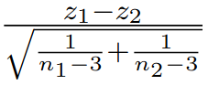where  and  are the standardized coupling values from CB and SC groups,  and  are the sample size of CB and SC groups. The cumulative distribution function (CDF, ) of the standard normal distribution to determine the significance of the  with the following formula: . The p-value of the coupling difference was calculated for all 360 ROIs across the cortex for each gradient, and the values were corrected with FDR for multiple comparisons.

In addition to the ROI-wise comparison of the coupling values, coupling strength across the whole cortex was calculated. We defined the coupling strength as the mean absolute coupling value across the whole cortex.

**2.4.4 Connectivity gradients within visual areas**

Connectivity gradients within visual areas were calculated separately to define functional organization within the visual cortex and how this organization differs in the CB group. Since the number of ROIs marked as "Visual" in the Glasser atlas is relatively low (26 unique regions), functional connectivity gradients were calculated vertex-wise. The vertices that correspond to "visual" areas according to Glasser areas were chosen in fsaverage5 mesh (Supplementary Figure 2). The selected vertices correspond to 2527 vertices out of 20484 that are available on fsaverage5 mesh. For each participant, preprocessed time series from those vertices were extracted and correlated with each other, resulting in 2527 x 2527 correlation matrices. The matrices are normalized via Fisher’s Z transformation.

The mean correlation matrix of the SC group was used to calculate the reference gradients that will be used to align the individual matrices. The reference gradient and the individual gradients were calculated using the same method and parameters that were used to calculate whole-brain connectivity gradients (see Section 2.3). After calculating the gradient scores for each vertex, the age and sex effects are removed using a linear regression model, and the residuals are compared between SC and CB groups via a between-sample t-test.

Vertex-wise cortical thickness, curvature, surface area, volume, and sulcal depth were used to measure the correlation between the gradient values and brain structure, and their differences in the CB group. PCA was applied to the five structural measures to create the common structural component. The effect of the scanning site was adjusted for at this step using the Combat method, and the effect of age and sex were removed together. Since Combat requires balanced samples from each site, Dataset 3 is removed from the analysis because it consists of CB participants only. Across V1, V2, V3, and V4, each participant’s gradient value (after removing the effect of age and sex) and the structural component were correlated with Spearman’s rank correlation. At the end of this step, each participant had a correlation value for each ROI. The correlation values were compared between SC and CB groups for each ROI and gradient.

3 - Results

## 3.1 Demographics

The groups did not significantly differ in age (number of CB = 41, mean age = 36.71 ± 14.46, number of SC = 44, mean age = 36.73 ± 13.79; t(83) = 0.004, p = 0.996) or sex distribution (CB = 21 male/20 female, SC = 20 male/24 female; X2 = 2.28, p = 0.595).

## 3.2 Connectivity gradients across neocortex

Functional connectivity gradients revealed the functional similarity profile of the cortical regions depending on how much variance they explain. On average, the first three gradients (G1, G2, G3) explained 59.68 % of the total variance for both groups (32.01% ± 0.07, 17.23% ± 0.03, and 10.45% ± 0.02, respectively). There were no differences in the explained variance of the gradients between the two groups (explained variances for each gradient were compared via a two-sample t-test, p > 0.05 for 10 gradients, corrected with FDR). The principal gradient G1 showed that brain activity is maximally organized between the unimodal/transmodal cortices. The second axis, G2, showed the visual and sensorimotor/auditory regions, and G3 showed the axis between the frontoparietal control network (FPN) and the rest of the brain (Figure 1A, Supplementary Figure 1).

Region-wise comparisons of the gradient scores showed that in all three gradients, the groups of CB individuals and SC significantly differed within visual regions (Figure 1B-D). In G1, the group of CB individuals had higher gradient scores in predominantly early, ventral, and lateral visual areas, suggesting those areas are less segregated from transmodal areas in CB individuals (Table S1 and S4). In addition, we observed higher gradient scores for G1 in several regions of the SMN and the DAN in CB individuals, suggesting that the SMN and the DAN are more segregated from transmodal areas in CB individuals than in SC. In G2, the group of CB individuals had lower gradient scores in predominantly early and ventral visual areas and higher gradient scores in the SMN, suggesting that in CB individuals early and ventral visual regions are more segregated from the SMN than in SC (Table S2 and S4). In G3, CB individuals had lower scores in predominantly early, dorsal, and lateral visual areas than SC, suggesting that these regions are closer to the FPN in CB individuals (Table S3 and S4). Overall, the functional profile of early, ventral, and lateral visual areas of CB individuals becomes more similar to that of higher-order regions, and the distinction between visual areas and sensorimotor areas is increased. Moreover, early, dorsal and lateral visual areas of CB individuals seem to become more functionally similar to the FPN. In addition, sensorimotor areas shifted away from the origin of the gradient axis in G2 in CB individuals, similar to what has been observed for visual regions.

The gradient range of G2 (defined as the maximum value of G2 minus the minimum value of G2) was higher in CB individuals (Figure 1C, t(83) = 4.81, p < 0.001). The same test was repeated for other gradients, but the differences did not reach statistical significance (all p > 0.05). Although the gradient range was related to the explained variance (Spearman’s Rho between gradient range and explained variance for G1: 0.85, G2: 0.43, G3: 0.26), the explained variances did not significantly differ between the groups of SC and CB individuals (all ps > 0.05). Another variable correlated with gradient range was gradient variance (correlation between G1 range and variance: 0.96, G2: 0.93, G3: 0.91). Here, we observed that the variance of G2 was higher in CB individuals compared to SC (t(83): 4.21, p < 0.001).

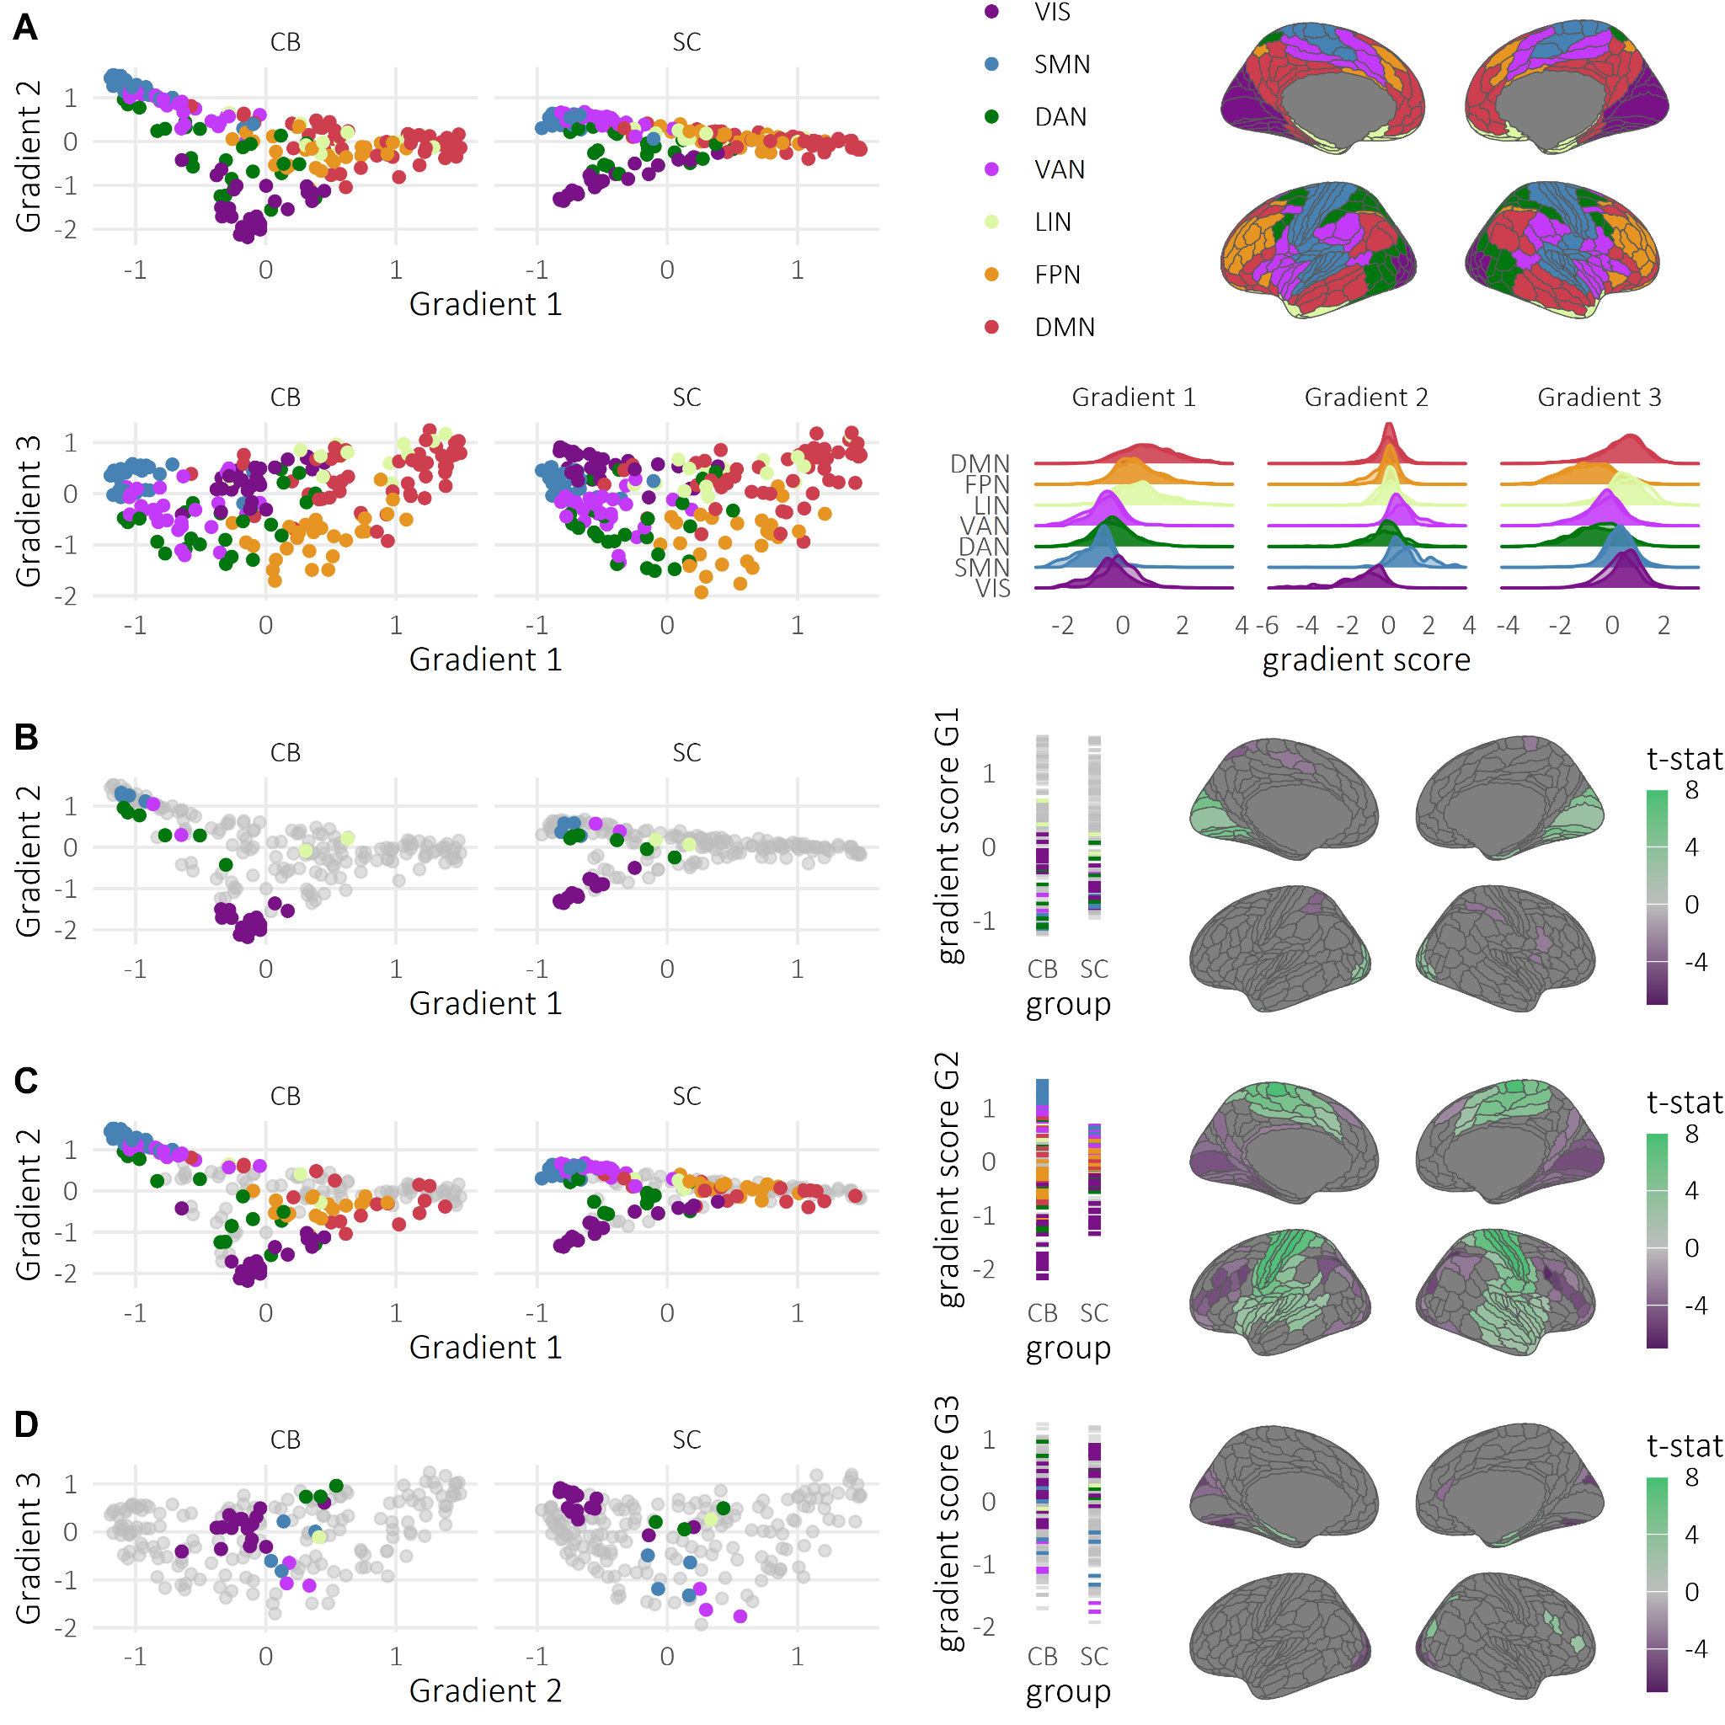

**Figure 1: Differences in macroscale functional organization between blind and sighted individuals.** **A** Distribution of gradient values across G1 and G2 (top-left panel) and across G1 and G3 (bottom-left panel) in the group of congenitally blind (CB) individuals and sighted controls (SC). Projection of 7 functional networks defined by Yeo et al. [62](https://www.zotero.org/google-docs/?QvCv2K) on ROIs defined by Glasser et al. [52](https://www.zotero.org/google-docs/?5XepBa) (top-right panel). Distribution of the gradient scores across 7 functional networks (transparent distribution: CB group, non-transparent distribution: SC group - bottom-right panel). **B-C-D:** Left-panels: Distribution of the gradient scores across SC and CB groups in 2D space. Regions showing significant differences in gradient scores between groups are colored by their respective network’s color. Mid-panels: Distribution of the gradient scores across SC and CB groups. Regions showing significant gradient scores between groups are colored by their respective network’s color. Right panels: Results of the region-wise comparison of the gradient scores between SC and CB groups (green color indicates higher values in CB group, corrected for multiple comparisons with FDR at p = 0.05). CB = congenitally blind; SC = sighted controls; VIS = visual network; SMN = somatosensory/ motor network; DAN = dorsal attention network; VAN = ventral attention network; LIN = limbic network; FPN = frontoparietal network; DMN = default mode network

## 3.3 Representation of the early visual areas in the embedding space

Figure 2 shows the ranking of each of the ROIs within early visual areas across gradients and groups. In G1 and G2, V1 had the lowest median rank, followed by V2, V4, and V3. The ranking distribution of G1 did not show any significant differences between the two groups (Table S6). In G2, both median and mode rank distribution were identical between the two groups (1-2-3-3 / 1-2-3-4). However, V1 of the group of CB individuals showed a higher rank than V1 of the group of SC (Wilcoxon Z = 3.15, p = 0.016), whereas V3 showed a lower rank in CB individuals (Wilcoxon Z = -2.56, p = 0.010). In G3, V1 and V2 had a higher rank in CB individuals, while V3 and V4 had a lower rank in the CB group (Wilcoxon Z scores = -2.59, -2.6, 3.01, 3.26, p-values < 0.001, results corrected with FDR). Taken together, these results suggest that the functional hierarchy within the visual system is altered in congenitally blind individuals.

*Minimum distances in G1.* The data summarized per group, gradient and ROI can be seen in Figure 2C. For the first gradient, the LMM on log(minimum distance) revealed a significant interaction between group and ROI (F(3, 249.00) = 3.74, p = 0.012). When we followed up on this interaction by comparing the log(minimum distances) between the groups in each ROI, none of the comparisons came out as significant.

*Minimum distances in G2.* For the second gradient, the LMM on log(minimum distance) revealed a significant interaction between group and ROI (F(3, 249.00) = 4.52, p = 0.004). Inspection of the EMMs and post-hoc tests revealed that the log(minimum distance) was greater in SC than CB individuals for V1 (see Table S8 for the EMMs (non-transformed data for ease of interpretability) and Table S9 for the post-hoc tests (performed on the log scale). This suggests that in G2, V1 is more functionally distinct from the other areas of the EVC (V2, V3, V4) in SC than CB individuals.

*Minimum distances in G3.* For the third gradient, the LMM on log(minimum distance) revealed a significant interaction between group and ROI (F(3, 249.00) = 9.66 , p < 0.001). Inspection of the EMMs and post-hoc tests revealed that the log(minimum distance) was greater in CB than SC individuals for V3 and V4 (see Table S10 for the EMMs (non-transformed data for ease of interpretability) and Table S11 for the post-hoc tests (performed on the log scale)). This suggests that in G3, V3 and V4 are more functionally distinct from V1 and V2 in CB individuals than in SC.

*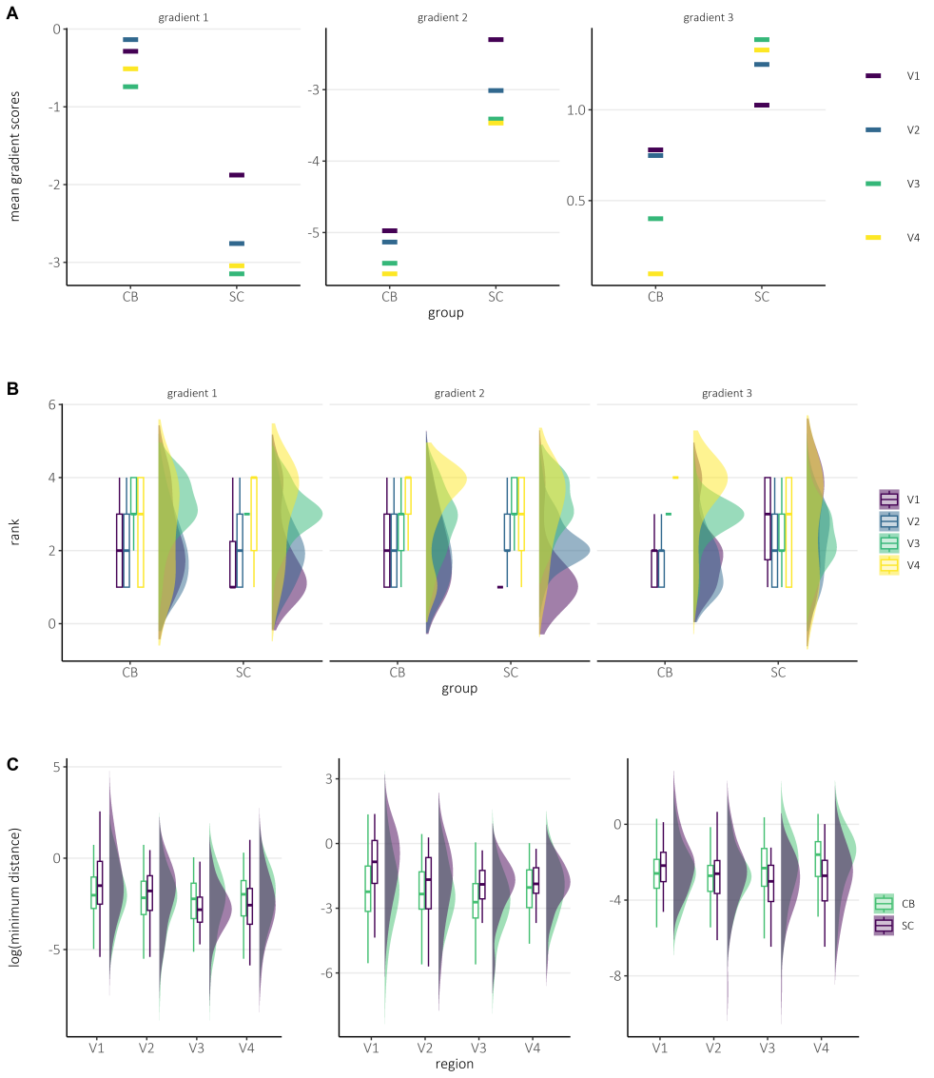***Figure 2: Differences in hierarchical organisation of the early visual cortex between congenitally blind individuals and sighted controls.** **A** Mean gradient scores of early visual areas. **B** Rank order of early visual areas. In the SC group, visual areas show a linear order, with V1 being the lowest, and V4 being the highest for G1 and G2. The rank of V1 is higher and V3 is lower in the CB group for G2. In G3, V1 and V2 rank higher, whereas V3 and V4 rank lower. **C** Minimum functional distance to the rest of the early visual regions. V1 is closer to the rest of the visual areas in G2 in congenitally blind individuals. CB = congenitally blind; SC = sighted controls

## 3.4 Connectivity gradients within visual areas

The first three connectivity gradients within visual areas explained 49% of the variance in SC (27.68% ± 10.33, 11.64% ± 2.52, 7.67% ± 1.94 for G1, G2, and G3 respectively). In CB individuals, G1 did not show any difference compared to that of SC (explained variance: 27.11 8.28, t(83): -0.31, p = 0.756), but G2 (explained variance: 15.14 3.73, t(83): 5.16, p = 0.001) and G3 (explained variance: 8.94 2.01, t(83): 2.91, p = 0.004) showed a higher explained variance in CB. In G1, the connectivity within visual areas is mainly organized between V1 and lateral occipital areas. In this axis, CB showed lower gradient scores in V1, specifically in the occipital pole, and higher values in MT+ (Figure 3A). G2 is organized along the posterior-anterior axis. In G2, the group of CB individuals had lower values in the dorsal stream and MT+. Lastly, G3 shows an organization between MT+ and the dorsal stream. Scores of the CB group increased in the dorsal stream and decreased in V1 (Figure 3A). Decomposition of the gradient scores by regions can be found in Supplementary Figure 3. Apart from the vertex-wise gradient scores, CB also differed in gradient range and variance in gradient scores in G2, but not in G1 and G3.

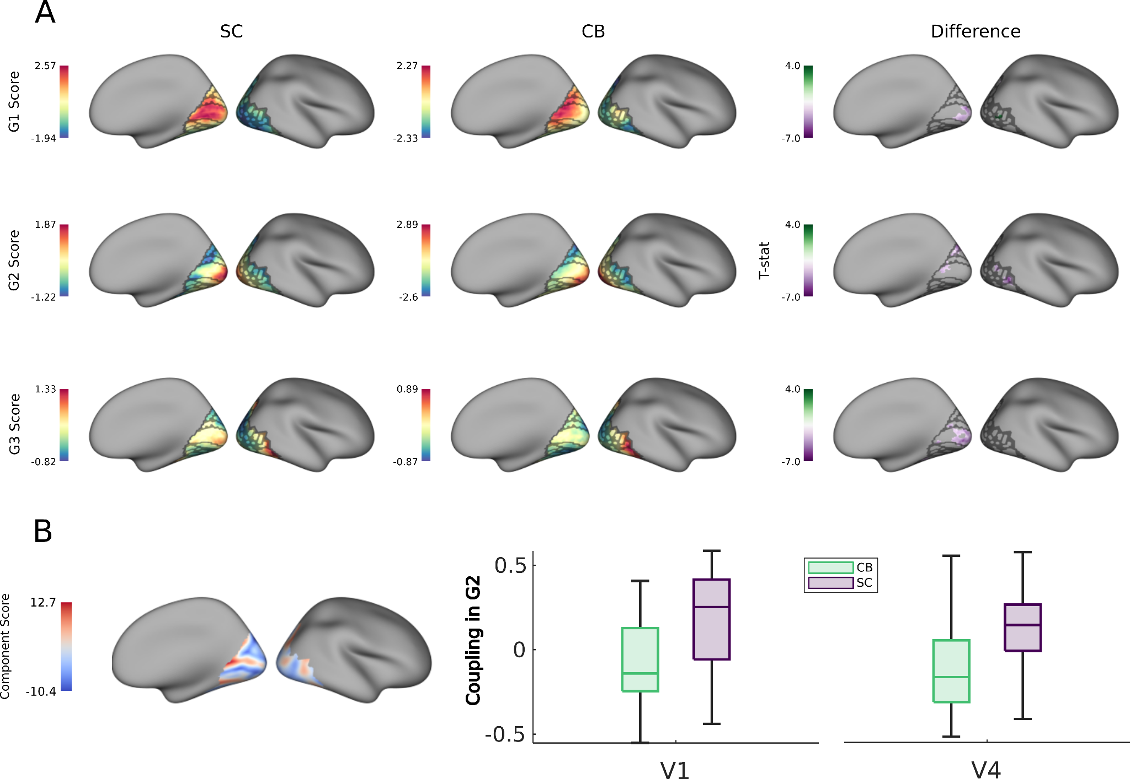

**Figure 3: Functional organization within visual areas.** **A** Gradients within visual areas. G1 shows that functional organization in visual areas is mainly defined by the functions from V1/V2 to the rest of the visual areas. G2 is shaped around the anterior-posterior axis, and G3 is organized within the dorsal stream. **B** Vertex-wise structural component within visual areas (left panel), and its mean coupling with G2 in V1 and V4 across two groups. CB group shows less coupling compared to SC.

## 3.5 Structure-function coupling

The principal structural component that was created for each participant using their cortical thickness, volume, surface area, sulcal depth, and curvature explained 98.43% ± 0.41 of variance (Figure 4A). Region-wise comparison between the structural component scores of SC and CB did not show any significant differences after correction for multiple comparisons. However, non-corrected p-values indicated that the group of CB individuals had lower structural scores in visual and sensorimotor areas, and higher scores in higher-order areas (Supplementary Figure 5).

In G1, the coupling between G1 and the structural component resembles the pattern of G1 itself, indicating a strong underlying structural mechanism for functional organization. Mean absolute coupling values across gradients and both groups were compared via a two-way ANOVA. The ANOVA revealed a significant interaction between group and gradient (F(2,2154) = 4.96, p = 0.007, Table S7). Tukey-kramer post-hoc tests revealed that G1’s mean absolute coupling value was significantly higher in SC than in CB individuals (mean absolute coupling value of SC = 0.31 ± 0.16, of CB = 0.19 ± 0.13, estimate = -0.053, p = 0.013, Figure 4C - right panel). When the coupling values for G1 in each ROI were compared between groups, visual (Figure 4B, regions colored with purple) and middle temporal areas (Figure 4B, regions colored in green, p < 0.05, corrected with FDR across whole-brain) showed a stronger coupling in the group of SC (Table S5).

In SC, the coupling between G2 and the structural component showed a similar pattern to G2 itself, that is, a positive coupling in sensorimotor areas and a negative coupling in visual areas (mean absolute coupling value: 0.10 ± 0.07). However, compared to G1, overall coupling strength decreased significantly, indicating a weaker coupling mechanism for G2 (estimate = -0.067, p < 0.001). These results indicate considerable but weaker structure-function coupling in G2 for the SC group compared to G1. By contrast, for the CB group, the coupling strength did not significantly differ between G1 and G2 (mean absolute coupling value for G1: 0.19 ± 0.13, for G2: 0.17 ± 0.11, estimate = 0.001, p = 0.999). No significant differences were observed in mean absolute structure-function coupling in G2 between CB individuals and SC (mean absolute coupling value of SC=0.10 ± 0.07, of CB= 0.17 ± 0.11), estimate = 0.012, p = 0.931). Lastly, ROI-wise comparisons of the coupling values between SC and CB groups did not reveal any significant differences.

The mean absolute coupling value in G3 for SC was 0.11 ± 0.09, and for CB was 0.13 ± 0.10. Compared to G1, overall coupling strength decreased significantly, indicating a weaker coupling mechanism for G3 (estimate = 0.067, p = 0.006). No significant differences between groups were observed in the mean absolute structure-function coupling in G3 (SC= 0.11 ± 0.09, CB = 0.13 ± 0.10, estimate = -0.001, p = 0.999) nor in the ROI-wise comparisons.

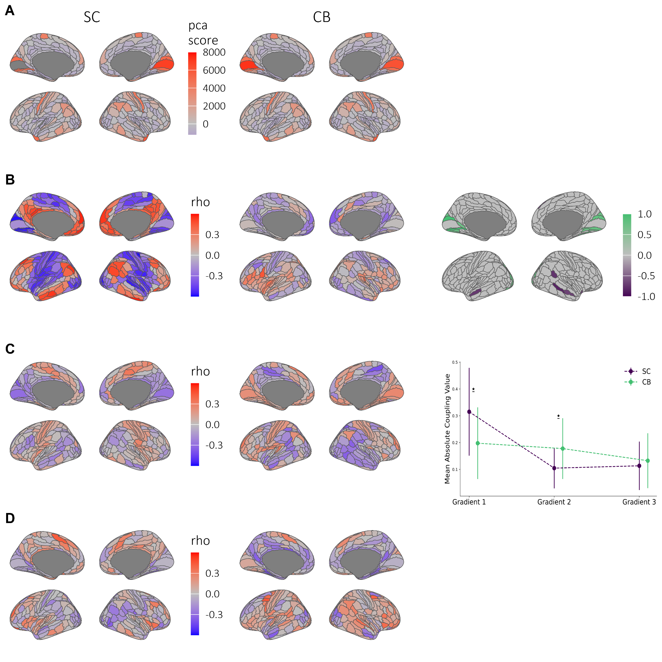

**Figure 4: Structural component and its correlation with gradients.** **A** Principal structural component for groups of sighted controls and congenitally blind individuals. **B-C-D** Coupling values between first 3 gradient scores and the first structural component. **B** Decreased structure-function coupling for G1 in the group of CB individuals in visual and temporal areas.

The structural component explains 94.56% ± 1.41 of the variance across vertex-wise cortical thickness that covers the visual areas only, volume, sulcal depth, surface area, and curvature (Figure 3B). Since it was calculated on the vertex level, unlike the ROI-based component, it shows finer structural details, such as sulci and gyri. The coupling between the structural component and the gradient scores across V1, V2, V3, and V4 showed that V1 and V4 have a decreased coupling with G2 for the CB group (mean V1-G2 coupling in SC: 0.16, 0.3, in CB: -0.08 ± 0.26, t(69): 3.65, p < 0.001; mean V4-G2 coupling in SC: 0.13 ± 0.2, in CB: -0.08 ± 0.24, t(69): 3.95, p < 0.001, Figure 3B, correlations of every ROI with ever gradient can be found in Supplementary Figure 4).

4 - Discussion

One of the main principles of human brain organization is the hierarchical arrangement within and between cortical networks. This hierarchical organization not only guides the flow of information, but also serves to separate higher-order areas from incoming environmental noise [1](https://www.zotero.org/google-docs/?jDyE4X). Here, we wanted to investigate whether this hierarchical organization is an innate feature of human brain organization or, instead, depends on sensory input during development. To this end, we compared functional connectivity gradients and their relationship to structural measurements between CB individuals and SC. Both groups showed a principal gradient that extended from unimodal to transmodal areas, a second gradient that extended from somatosensory to visual areas, as well as a third gradient that extended between the FPN and the rest of the brain. These findings suggest that the broad macroscale organization of the brain develops independently of sensory experience. However, in CB individuals, G1 was contracted between early, ventral, and lateral visual and transmodal areas, G2 expanded between the somatosensory/motor and visual regions, and G3 was contracted between early, dorsal and lateral visual areas and the FPN. Additionally, we observed that the hierarchy and the functional connectome within EVC were altered in the CB group. Structural results indicate reduced structural functional coupling in visual and temporal regions for G1 in CB individuals. Taken together, the results of this study suggest that visual experience is essential for refining a presumably innate functional hierarchical organization within and between cortical networks.

## Connectivity gradients across the neocortex

Previously, it has been suggested that the hierarchical organization of the cortex is necessary for sensory signals to be transformed into more abstract representations. In CB individuals, we observed a reduced functional segregation between early, ventral, and lateral visual areas and transmodal areas, along with a concomitant increase in functional segregation between early and ventral visual areas and sensorimotor areas. Previous research indicates that blind individuals engage early, ventral, and lateral visual areas during spoken language processing [4,5,63,64](https://www.zotero.org/google-docs/?XwyrRK). Crucially, responses to language in these areas have been shown to be modulated by grammatical complexity and semantic semantic content of the stimuli, with activity being greater for stimuli that have meaning and grammatical structure [4,7,63,64](https://www.zotero.org/google-docs/?52DYcF). These findings provide strong evidence for the notion that information processed by visual cortices of blind individuals during language tasks is symbolic and abstract, rather than sensory [65](https://www.zotero.org/google-docs/?jF9JkJ).

It could be argued that the visual cortices can take on these new higher-level functions and process abstract information because of their functional distance to other networks. In fact, there is now emerging consensus that the role of the higher-level regions in cognition relates to their physical and functional distance from the sensory and motor systems [1,66](https://www.zotero.org/google-docs/?eOFlSd). For example, the DMN exhibits the greatest physical and functional distance along the cortical surface and is equidistant from primary sensory and motor areas [1](https://www.zotero.org/google-docs/?mz9oXv). This topographical organization is thought to enable it to process supramodal information that is independent of immediate sensory input [1,2,66](https://www.zotero.org/google-docs/?O0WDzt). Similarly, it could be argued that the increased functional segregation between early and ventral visual regions and regions of the SMN in CB individuals is a necessary prerequisite for the processing of abstract (linguistic) information in these regions.

In the third gradient, we observed a reduced functional segregation between a network of early visual (V3 and V4) and predominantly dorsal visual areas and the FPN. The FPN is thought to play a central role in cognitive control by coordinating task demands and goals, and by modulating processing in other brain regions through top-down mechanisms [67,68](https://www.zotero.org/google-docs/?eSUy2Z). It has been suggested that the FPN may gain its multiple demand ability by flexibly interacting with a variety of functionally specialized brain networks [68,69](https://www.zotero.org/google-docs/?QUdv3s). This adaptive regulation allows for the efficient implementation of task requirements across different cognitive domains [67,69](https://www.zotero.org/google-docs/?nBvuRG). Similarly, the visual cortices of blind individuals have been shown to play a role in a number of different cognitive domains and to interact with functionally specialized networks across the brain [6,7,9,65,70](https://www.zotero.org/google-docs/?ZKytjX). Based on this, it could be hypothesized that dorsal visual cortices of blind individuals become part of the FPN [42](https://www.zotero.org/google-docs/?vmEfd7).

Overall it seems like dorsal regions become functionally more similar to the FPN, while the early visual (V1 and V2) and ventral visual areas become functionally more similar to other transmodal areas. This is not only supported by our findings in the first and third gradient, but also by the finding that mostly early and ventral visual areas seem to be more functionally distinct from regions of the SMN than dorsal areas. This latter finding is consistent with previous studies that have reported greater decrease in rsFC between S1 and early and ventral visual regions in blind individuals, compared to dorsal visual regions [71](https://www.zotero.org/google-docs/?JmQF0O). Thus, it seems like a functional segregation between dorsal and ventral visual areas is retained in blind individuals. Indeed, while early (V1 and V2) and ventral “visual stream” areas in blind individuals have been associated with language [4](https://www.zotero.org/google-docs/?hgyXIc), reading [5](https://www.zotero.org/google-docs/?d7OWRQ), and object recognition [72](https://www.zotero.org/google-docs/?ZAhATZ), whereas dorsal “visual stream” regions have been associated with the processing of auditory motion [73](https://www.zotero.org/google-docs/?Q0Iq6y) and numerical cognition [6](https://www.zotero.org/google-docs/?subZhk). Moreover, in blind individuals, activity of number-responsive visual areas has been shown to be correlated at rest with frontoparietal number areas, whereas language responsive regions of visual cortex are correlated with prefrontal language regions [6,45](https://www.zotero.org/google-docs/?0wwhL1).

## Changed hierarchy within early visual areas

Previously, it has been suggested that blindness alters the functional hierarchy within the visual cortex [74](https://www.zotero.org/google-docs/?C8r5NG). For example, Rakic et al. [75](https://www.zotero.org/google-docs/?v0fnGJ) have shown that in enucleated macaques, a novel cytoarchitectonic area emerges between V1 and V2, combining features of both primary visual and extrastriate cortex. This region, also known as the *hybrid cortex* [74](https://www.zotero.org/google-docs/?v3G4FU), was recently shown to occupy a relatively high position in the cortical hierarchy and to receive enhanced input from ventral stream areas [74](https://www.zotero.org/google-docs/?GwMFSN). In our study, we observed that V1 in G2 and both V1 and V2 in G3 had a higher rank in CB individuals compared to SC. These findings provide further evidence for the notion that blindness alters the hierarchical organization of the visual cortex.

Although no study has yet identified the development of a novel cytoarchitectonic area in blind humans, it seems plausible that similar mechanisms occur as observed in enucleated macaques in the study by Magrou et al. [74](https://www.zotero.org/google-docs/?EUyKVc). Specifically, in the absence of feedforward input to V1, it likely receives reinforced input from higher-order areas, altering its position within the functional hierarchy of the visual cortex. This could also explain the finding that in G2 and G3, V1 was functionally less distinct from the rest of the EVC (V2, V3, and V4) in CB individuals. That is, the lack of feedforward input from the LGN to V1 in CB individuals, could decrease its functional segregation of V1 from the rest of EVC.

## Altered functional clustering in congenitally blind individuals

Next, we aimed to assess connectivity gradients within visual areas to further explore potential changes in its functional organization in CB individuals. Previous studies have demonstrated that cortical parcellations based on rsFC gradients closely align with task activation maps and show strong correspondence with probabilistic delineations of V1 and V2 [40,41](https://www.zotero.org/google-docs/?XQ2Kbp). Consistent with these findings, we observed a correspondence between the V1-V2 areal borders and G1 in SC. However, in CB individuals, this correspondence was absent at the dorsal border. This finding is consistent with findings from Striem-Amit et al. [9](https://www.zotero.org/google-docs/?HNLyDH) who compared the connectivity pattern from a seed in V1 with that of a seed in the same visual field in V2. They reported that while the entire ventral border between V1 and V2 could be constructed using rsFC maps in blind individuals, the dorsal border was not clearly visible [9](https://www.zotero.org/google-docs/?F0ojrD). These results suggest that visual input may be necessary for the refinement of areal borders.

Moreover, in CB individuals probabilistic V1 appeared to be split into two distinct functional clusters: the occipital pole exhibited increased functional similarity to ventral occipitotemporal areas, while the rest of V1 formed a cohesive cluster with dorsal V3. Changes in functional organisation were also observed in G3, where we observed that in CB individuals the occipital pole became functionally more integrated with V3 and V4, as well as lateral visual regions, whereas in SC it was functionally more integrated with the apex of the dorsal and ventral visual stream. Previously, it has been observed that the occipital pole (typically representing the center of the visual field) and the rest of V1 (typically representing the periphery of the visual field) are connected to different areas in the frontal cortex in blind individuals: the occipital pole showed increased functional connectivity to the inferior frontal gyrus, particularly in the left hemisphere, whereas the peripheral V1 showed stronger functional connectivity to the dorsolateral prefrontal cortex [9](https://www.zotero.org/google-docs/?YqLuUk). These findings provide further evidence for the notion that the lack of visual input during development leads to changes in areal specialization. This dovetails nicely with our findings of a changed hierarchy in CB individuals and the increased functional coupling of the occipital pole with ventral occipitotemporal areas, which has also been observed for the hybrid cortex in enucleated macaques [74](https://www.zotero.org/google-docs/?j7M2zQ).

## Reduced structure-function coupling in congenitally blind individuals

The coupling between G1 and the structural component mirrored the overall pattern of G1, suggesting a robust structural mechanism underlying its functional organization. However, in CB individuals, we observed reduced structure-function coupling in visual and middle temporal areas. Studies that have assessed structure-function coupling using structural connectivity as a proxy for structure, have reported strong structure-function coupling in ventral and early visual areas as early as 1 and 2 years of age, with continued strengthening up to at least 6 years of age [76](https://www.zotero.org/google-docs/?fnIR7P). Other studies that have looked into structure-function coupling using gross morphological measures have also reported a strengthening of structure-function coupling from childhood to adulthood [77](https://www.zotero.org/google-docs/?eQDbmR). Taken together, these findings suggest that structure-function coupling within visual areas is already established in early childhood and continues to be strengthened throughout development. Our results suggest that the development of this structure-function coupling is dependent on sensory input during development.

Recent evidence indicates that increased myelination and a lower excitation-inhibition (EI) ratio are linked to more rigid structure-function coupling [78](https://www.zotero.org/google-docs/?EYc5Nx). While myelination has not yet been investigated in CB individuals, there is indirect evidence to suggest reduced myelination of the occipital cortices of CB individuals. Previous studies have shown that the visual cortices of CB individuals have increased cortical thickness as measured by MRI [15,17,18](https://www.zotero.org/google-docs/?0pFHdS) and that increased apparent cortical thickness of visual areas may represent lower myelination [79](https://www.zotero.org/google-docs/?JrIfKL). Moreover, there is evidence to suggest that the EI ratio is increased in blind individuals [80,81](https://www.zotero.org/google-docs/?VYo6PH). Based on these findings, it could be hypothesised that the reduced structure-function coupling observed in CB individuals, particularly in the visual cortices, may stem from reduced myelination and an increased EI ratio.

It should be noted that this lack of structure-function coupling, particularly in visual regions, in blind individuals could also be the result of applying a uniform parcellation to all participants. This entails the assumption that functional areas can be mapped to identical spatial locations in all participants [82](https://www.zotero.org/google-docs/?i4z9F1). However, as we have shown here, the functional organization within visual areas seems to be altered in blind individuals, particularly in early visual regions. Not only did we find evidence for changes of the hierarchical organization, but the results from the connectivity gradients within visual areas suggest that the areal specialization between areas may differ between CB individuals and SC. Thus, structure-function relationships may not be perfectly captured if the areas are not correctly aligned with the functional organization, as seems to be the case in CB individuals. A key challenge for future research on structure–function coupling in sensory deprived individuals is how to reconstruct networks while accounting for individual variations in topographic organization [82](https://www.zotero.org/google-docs/?W9bOuk). One possibility could be to create individual cortical area parcellations using rsFC [40,83](https://www.zotero.org/google-docs/?4QTRSJ).

It should be noted that previous studies have reported a tight coupling between structure and function in primary sensory and motor areas, whereas in transmodal association areas, structure and function appear to diverge [30–33,see 84 for a review](https://www.zotero.org/google-docs/?qBngG4). By contrast, we observed a structure-function coupling axis that showed strong coupling in visual and sensorimotor areas, as well as in transmodal areas, with weaker associations between structure and function in intermediate regions. These divergent results could be explained by the different proxies for structure that have been used in our study, compared to previous studies. Most studies that have looked at structure-function coupling in the macroscale organization of the brain have mostly relied on structural connectivity as a proxy for structure [see 82 for a review](https://www.zotero.org/google-docs/?jrBKfs), whereas we used a composite derived from a PCA analysis that included mean cortical thickness, curvature, sulcal depth, surface area, and volume. Previous studies have shown a close correspondence between these gross morphological measures and functional specialization. For example, in V1, surface topology is predictive of the underlying retinotopic organization [85](https://www.zotero.org/google-docs/?bDY3LQ). And even in higher-level visual areas, there seems to be a close correspondence between sulcal folds and functional specialization [86,87](https://www.zotero.org/google-docs/?Htkg5a). These findings show that gross morphological measurements are highly suitable for studying structure-function relationships.

## Conclusion

In conclusion, our findings suggest that while the broad macroscale hierarchical organization of the brain develops independently of sensory experience, visual input plays a critical role in refining this organization. CB and SC individuals exhibited similar large-scale gradients, indicating an innate framework. However, distinct alterations in gradient patterns and functional connectivity within EVC in CB individuals highlight the importance of visual experience in fine-tuning these cortical hierarchies. Notably, this study is the first to demonstrate reduced structure-function coupling in visual and temporal regions specifically linked to altered gradients in CB individuals. These results underscore the interplay between innate brain organization and sensory-driven refinement, particularly within visual networks.

# Data availability

The scripts used in this study are available at <https://github.com/KobaCemal/BlindnessGradients> and <https://github.com/LenaStroh/BlindnessGradients> .

# Acknowledgements

Cemal Koba and Joan Falcó-Roget were supported by the project of the Minister of Science and Higher Education "Support for the activity of Centers of Excellence established in Poland under Horizon 2020" on the basis of the contract number MEiN/2023/DIR/379, and the European Union’s Horizon 2020 research and innovation programme under grant agreement No 857533, and by Sano project carried out within the International Research Agendas programme of the Foundation for Polish Science, co-financed by the European Union under the European Regional Development Fund. This research was supported in part by the PLGrid infrastructure. Computations have been partially performed on the ARES439 supercomputer at ACC Cyfronet AGH. Anna-Lena Stroh and Marcin Szwed were supported by the Polish National Science Centre (NCN; grant no: 2018/30/A/HS6/00595).

# Supplementary Materials

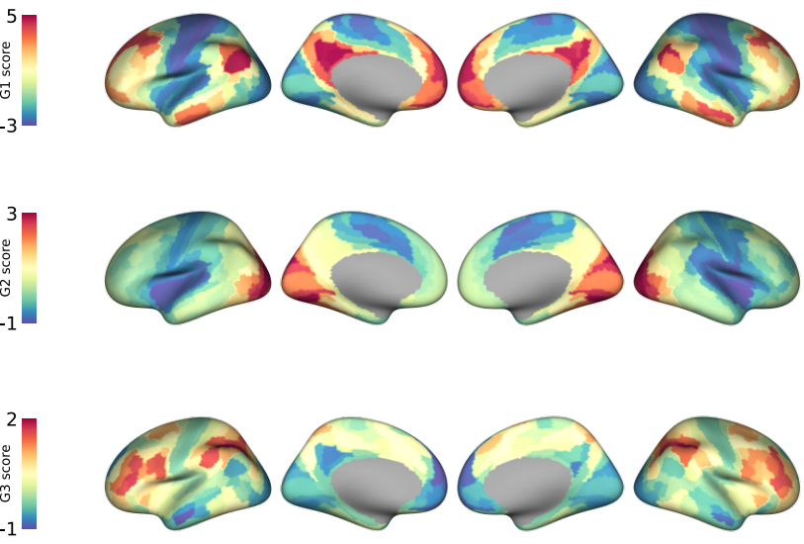

**Supplementary Figure 1:** First three gradients in SC.

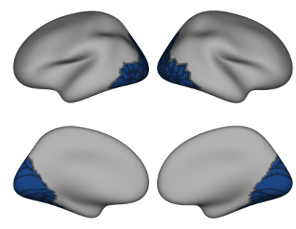

**Supplementary Figure 2 |** Network mask used to calculate connectivity gradients within visual areas.

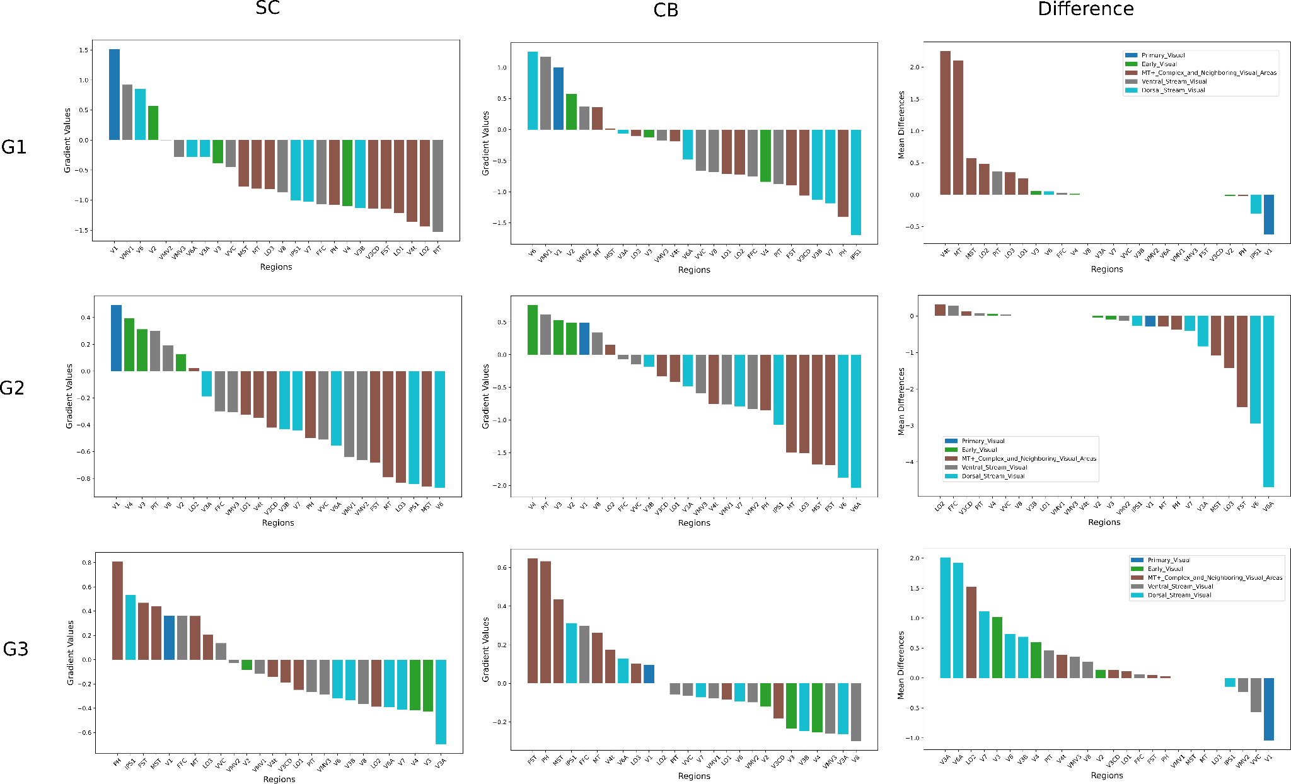

**Supplementary Figure 3 |** Decomposition of the vertex-wise gradients and their differences across visual regions. Left column: Mean gradients values across regions for SC group. Mid panel: Mean gradients values across regions for CB group. Right column: Mean t-score of differences across regions (CB-SC).

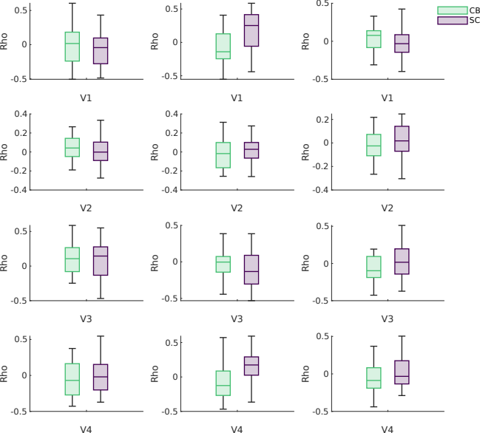

**Supplementary Figure 4 |** Structure-function coupling within visual areas across gradients.

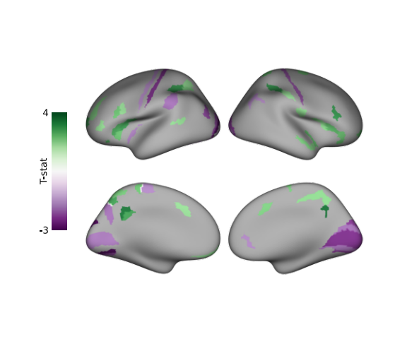

**Supplementary Figure 5 |** Uncorrected difference map of the structural component (CB>SC). CB group showed lower component scores in visual and somatomotor areas, and higher scores in higher-order areas (p<0.05)

# References

[1. Margulies, D. S. *et al.* Situating the default-mode network along a principal gradient of macroscale cortical organization. *Proc. Natl. Acad. Sci. U.S.A.* **113**, 12574–12579 (2016).](https://www.zotero.org/google-docs/?MrUNX2)

[2. Mesulam, M. From sensation to cognition. *Brain* **121**, 1013–1052 (1998).](https://www.zotero.org/google-docs/?MrUNX2)

[3. Fine, I. & Park, J.-M. Blindness and Human Brain Plasticity. *Annu. Rev. Vis. Sci.* **4**, 337–356 (2018).](https://www.zotero.org/google-docs/?MrUNX2)

[4. Bedny, M., Pascual-Leone, A., Dodell-Feder, D., Fedorenko, E. & Saxe, R. Language processing in the occipital cortex of congenitally blind adults. *Proceedings of the National Academy of Sciences* **108**, 4429–4434 (2011).](https://www.zotero.org/google-docs/?MrUNX2)

[5. Dzięgiel-Fivet, G. *et al.* Neural network for Braille reading and the speech-reading convergence in the blind: Similarities and differences to visual reading. *NeuroImage* **231**, 117851 (2021).](https://www.zotero.org/google-docs/?MrUNX2)

[6. Kanjlia, S., Lane, C., Feigenson, L. & Bedny, M. Absence of visual experience modifies the neural basis of numerical thinking. *Proc Natl Acad Sci USA* **113**, 11172–11177 (2016).](https://www.zotero.org/google-docs/?MrUNX2)

[7. Abboud, S. & Cohen, L. Distinctive Interaction Between Cognitive Networks and the Visual Cortex in Early Blind Individuals. 18 (2019) doi:10.1093/cercor/bhz 006.](https://www.zotero.org/google-docs/?MrUNX2)

[8. Deen, B., Saxe, R. & Bedny, M. Occipital Cortex of Blind Individuals Is Functionally Coupled with Executive Control Areas of Frontal Cortex. *Journal of Cognitive Neuroscience* **27**, 1633–1647 (2015).](https://www.zotero.org/google-docs/?MrUNX2)

[9. Striem-Amit, E. *et al.* Functional connectivity of visual cortex in the blind follows retinotopic organization principles. *Brain* **138**, 1679–1695 (2015).](https://www.zotero.org/google-docs/?MrUNX2)

[10. Butt, O. H., Benson, N. C., Datta, R. & Aguirre, G. K. The Fine-Scale Functional Correlation of Striate Cortex in Sighted and Blind People. *J. Neurosci.* **33**, 16209–16219 (2013).](https://www.zotero.org/google-docs/?MrUNX2)

[11. Kanjlia, S., Pant, R. & Bedny, M. *Sensitive Period for Cognitive Repurposing of Human Visual Cortex*. http://biorxiv.org/lookup/doi/10.1101/402321 (2018) doi:10.1101/402321.](https://www.zotero.org/google-docs/?MrUNX2)

[12. Liu, Y. *et al.* Whole brain functional connectivity in the early blind. *Brain* **130**, 2085–2096 (2007).](https://www.zotero.org/google-docs/?MrUNX2)

[13. Wang, D. *et al.* Altered resting‐state network connectivity in congenital blind. *Human Brain Mapping* **35**, 2573–2581 (2014).](https://www.zotero.org/google-docs/?MrUNX2)

[14. Bridge, H., Cowey, A., Ragge, N. & Watkins, K. Imaging studies in congenital anophthalmia reveal preservation of brain architecture in ‘visual’ cortex. *Brain* **132**, 3467–3480 (2009).](https://www.zotero.org/google-docs/?MrUNX2)

[15. Jiang, J. *et al.* Thick Visual Cortex in the Early Blind. *Journal of Neuroscience* **29**, 2205–2211 (2009).](https://www.zotero.org/google-docs/?MrUNX2)

[16. Park, H.-J., Lee, J. D. & Kim, E. Y. Morphological alterations in the congenital blind based on the analysis of cortical thickness and surface area | Elsevier Enhanced Reader. (2009) doi:10.1016/j.neuroimage.2009.03.076.](https://www.zotero.org/google-docs/?MrUNX2)

[17. Stroh, A.-L. *et al.* Blind individuals’ enhanced ability to sense their own heartbeat is related to the thickness of their occipital cortex. *Cerebral Cortex* **34**, bhae324 (2024).](https://www.zotero.org/google-docs/?MrUNX2)

[18. Hölig, C., Guerreiro, M. J. S., Lingareddy, S., Kekunnaya, R. & Röder, B. Sight restoration in congenitally blind humans does not restore visual brain structure. *Cerebral Cortex* bhac197 (2022) doi:10.1093/cercor/bhac197.](https://www.zotero.org/google-docs/?MrUNX2)

[19. Markov, N. T. & Kennedy, H. The importance of being hierarchical. *Current Opinion in Neurobiology* **23**, 187–194 (2013).](https://www.zotero.org/google-docs/?MrUNX2)

[20. Taylor, H. P. *et al.* Functional Hierarchy of the Human Neocortex from Cradle to Grave. Preprint at https://doi.org/10.1101/2024.06.14.599109 (2024).](https://www.zotero.org/google-docs/?MrUNX2)

[21. Zhang, J. *et al.* Intrinsic Functional Connectivity is Organized as Three Interdependent Gradients. *Sci Rep* **9**, 15976 (2019).](https://www.zotero.org/google-docs/?MrUNX2)

[22. Bethlehem, R. A. I. *et al.* Dispersion of functional gradients across the adult lifespan. *NeuroImage* **222**, 117299 (2020).](https://www.zotero.org/google-docs/?MrUNX2)

[23. Friston, K. Functional integration and inference in the brain. *Progress in Neurobiology* **68**, 113–143 (2002).](https://www.zotero.org/google-docs/?MrUNX2)

[24. Valk, S. L. *et al.* Functional and microstructural plasticity following social and interoceptive mental training. *eLife* **12**, e85188 (2023).](https://www.zotero.org/google-docs/?MrUNX2)

[25. Demirtaş, M. *et al.* Hierarchical Heterogeneity across Human Cortex Shapes Large-Scale Neural Dynamics. *Neuron* **101**, 1181-1194.e13 (2019).](https://www.zotero.org/google-docs/?MrUNX2)

[26. Huntenburg, J. M. *et al.* A Systematic Relationship Between Functional Connectivity and Intracortical Myelin in the Human Cerebral Cortex. *Cerebral Cortex* **27**, 981–997 (2017).](https://www.zotero.org/google-docs/?MrUNX2)

[27. Wagstyl, K., Ronan, L., Goodyer, I. M. & Fletcher, P. C. Cortical thickness gradients in structural hierarchies. *NeuroImage* **111**, 241–250 (2015).](https://www.zotero.org/google-docs/?MrUNX2)

[28. Vos de Wael, R. *et al.* Structural Connectivity Gradients of the Temporal Lobe Serve as Multiscale Axes of Brain Organization and Cortical Evolution. *Cerebral Cortex* **31**, 5151–5164 (2021).](https://www.zotero.org/google-docs/?MrUNX2)

[29. Bernhardt, B. C., Smallwood, J., Keilholz, S. & Margulies, D. S. Gradients in brain organization. *NeuroImage* **251**, 118987 (2022).](https://www.zotero.org/google-docs/?MrUNX2)

[30. Baum, G. L. *et al.* Development of structure–function coupling in human brain networks during youth. *Proc Natl Acad Sci USA* **117**, 771–778 (2020).](https://www.zotero.org/google-docs/?MrUNX2)

[31. Paquola, C. *et al.* Microstructural and functional gradients are increasingly dissociated in transmodal cortices. *PLOS Biology* **17**, e3000284 (2019).](https://www.zotero.org/google-docs/?MrUNX2)

[32. Preti, M. G. & Van De Ville, D. Decoupling of brain function from structure reveals regional behavioral specialization in humans. *Nat Commun* **10**, 4747 (2019).](https://www.zotero.org/google-docs/?MrUNX2)

[33. Vázquez-Rodríguez, B. *et al.* Gradients of structure–function tethering across neocortex. *Proceedings of the National Academy of Sciences* **116**, 21219–21227 (2019).](https://www.zotero.org/google-docs/?MrUNX2)

[34. Haak, K. V., Marquand, A. F. & Beckmann, C. F. Connectopic mapping with resting-state fMRI. *NeuroImage* **170**, 83–94 (2018).](https://www.zotero.org/google-docs/?MrUNX2)

[35. Ngo, G. N., Haak, K. V., Beckmann, C. F. & Menon, R. S. Mesoscale hierarchical organization of primary somatosensory cortex captured by resting-state-fMRI in humans. *NeuroImage* **235**, 118031 (2021).](https://www.zotero.org/google-docs/?MrUNX2)

[36. Song, Y. *et al.* Functional hierarchy of the angular gyrus and its underlying genetic architecture. *Human Brain Mapping* **44**, 2815–2828 (2023).](https://www.zotero.org/google-docs/?MrUNX2)

[37. Tian, Y. & Zalesky, A. Characterizing the functional connectivity diversity of the insula cortex: Subregions, diversity curves and behavior. *NeuroImage* **183**, 716–733 (2018).](https://www.zotero.org/google-docs/?MrUNX2)

[38. Wang, R. *et al.* Functional connectivity gradients of the insula to different cerebral systems. *Human Brain Mapping* **44**, 790–800 (2023).](https://www.zotero.org/google-docs/?MrUNX2)

[39. Shen, Y. *et al.* Functional connectivity gradients of the cingulate cortex. *Commun Biol* **6**, 1–9 (2023).](https://www.zotero.org/google-docs/?MrUNX2)

[40. Gordon, E. M. *et al.* Generation and Evaluation of a Cortical Area Parcellation from Resting-State Correlations. *Cereb. Cortex* **26**, 288–303 (2016).](https://www.zotero.org/google-docs/?MrUNX2)

[41. Wig, G. S., Laumann, T. O. & Petersen, S. E. An approach for parcellating human cortical areas using resting-state correlations. *NeuroImage* **93**, 276–291 (2014).](https://www.zotero.org/google-docs/?MrUNX2)

[42. Pelland, M. *et al.* State-dependent modulation of functional connectivity in early blind individuals. *NeuroImage* **147**, 532–541 (2017).](https://www.zotero.org/google-docs/?MrUNX2)

[43. Gorgolewski, K. J. *et al.* The brain imaging data structure, a format for organizing and describing outputs of neuroimaging experiments. *Sci Data* **3**, 160044 (2016).](https://www.zotero.org/google-docs/?MrUNX2)

[44. Bedny, M. & Tian, M. Blindness Resting State. ICPSR - Interuniversity Consortium for Political and Social Research https://doi.org/10.3886/E198832V1 (2024).](https://www.zotero.org/google-docs/?MrUNX2)

[45. Tian, M., Xiao, X., Hu, H., Cusack, R. & Bedny, M. Visual experience shapes functional connectivity between occipital and non-visual networks. *eLife* **13**, (2024).](https://www.zotero.org/google-docs/?MrUNX2)

[46. Cruces, R. R. *et al.* Micapipe: A pipeline for multimodal neuroimaging and connectome analysis. *NeuroImage* **263**, 119612 (2022).](https://www.zotero.org/google-docs/?MrUNX2)

[47. Cox, R. W. AFNI: software for analysis and visualization of functional magnetic resonance neuroimages. *Comput Biomed Res* **29**, 162–173 (1996).](https://www.zotero.org/google-docs/?MrUNX2)

[48. Jenkinson, M., Beckmann, C. F., Behrens, T. E. J., Woolrich, M. W. & Smith, S. M. FSL. *Neuroimage* **62**, 782–790 (2012).](https://www.zotero.org/google-docs/?MrUNX2)

[49. Avants, B. B., Epstein, C. L., Grossman, M. & Gee, J. C. Symmetric diffeomorphic image registration with cross-correlation: Evaluating automated labeling of elderly and neurodegenerative brain. *Medical Image Analysis* **12**, 26–41 (2008).](https://www.zotero.org/google-docs/?MrUNX2)

[50. Dale, A. M., Fischl, B. & Sereno, M. I. Cortical Surface-Based Analysis: I. Segmentation and Surface Reconstruction. *NeuroImage* **9**, 179–194 (1999).](https://www.zotero.org/google-docs/?MrUNX2)

[51. Henschel, L. *et al.* FastSurfer - A fast and accurate deep learning based neuroimaging pipeline. *NeuroImage* **219**, 117012 (2020).](https://www.zotero.org/google-docs/?MrUNX2)

[52. Glasser, M. F. *et al.* A multi-modal parcellation of human cerebral cortex. *Nature* **536**, 171–178 (2016).](https://www.zotero.org/google-docs/?MrUNX2)

[53. Satterthwaite, T. D. *et al.* An improved framework for confound regression and filtering for control of motion artifact in the preprocessing of resting-state functional connectivity data. *Neuroimage* **64**, 240–256 (2013).](https://www.zotero.org/google-docs/?MrUNX2)

[54. Vos de Wael, R. *et al.* BrainSpace: a toolbox for the analysis of macroscale gradients in neuroimaging and connectomics datasets. *Commun Biol* **3**, 1–10 (2020).](https://www.zotero.org/google-docs/?MrUNX2)

[55. Worsley, K. *et al.* SurfStat: A Matlab toolbox for the statistical analysis of univariate and multivariate surface and volumetric data using linear mixed effects models and random field theory. *NeuroImage* **47**, S102 (2009).](https://www.zotero.org/google-docs/?MrUNX2)

[56. Posit team. Rstudio: Integrated. Posit Software, PBC (2024).](https://www.zotero.org/google-docs/?MrUNX2)

[57. Singmann, H., Bolker, B., Westfall, J., Aust, F. & Ben-Shachar, M. S. _afex: Analysis of Factorial Experiments_. (2023).](https://www.zotero.org/google-docs/?MrUNX2)

[58. Lenth, R. V. _emmeans: Estimated Marginal Means, aka Least-Squares Means_. (2023).](https://www.zotero.org/google-docs/?MrUNX2)

[59. Fortin, J.-P. *et al.* Harmonization of multi-site diffusion tensor imaging data. *NeuroImage* **161**, 149–170 (2017).](https://www.zotero.org/google-docs/?MrUNX2)

[60. Fortin, J.-P. *et al.* Harmonization of cortical thickness measurements across scanners and sites. *Neuroimage* **167**, 104–120 (2018).](https://www.zotero.org/google-docs/?MrUNX2)

[61. Johnson, W. E., Li, C. & Rabinovic, A. Adjusting batch effects in microarray expression data using empirical Bayes methods. *Biostatistics* **8**, 118–127 (2007).](https://www.zotero.org/google-docs/?MrUNX2)

[62. Yeo, B. T. T. *et al.* The organization of the human cerebral cortex estimated by intrinsic functional connectivity. *Journal of Neurophysiology* **106**, 1125–1165 (2011).](https://www.zotero.org/google-docs/?MrUNX2)

[63. Kim, J. S., Kanjlia, S., Merabet, L. B. & Bedny, M. Development of the Visual Word Form Area Requires Visual Experience: Evidence from Blind Braille Readers. *J. Neurosci.* **37**, 11495–11504 (2017).](https://www.zotero.org/google-docs/?MrUNX2)

[64. Lane, C., Kanjlia, S., Omaki, A. & Bedny, M. ‘Visual’ Cortex of Congenitally Blind Adults Responds to Syntactic Movement. *Journal of Neuroscience* **35**, 12859–12868 (2015).](https://www.zotero.org/google-docs/?MrUNX2)

[65. Bedny, M. Evidence from Blindness for a Cognitively Pluripotent Cortex. *Trends in Cognitive Sciences* **21**, 637–648 (2017).](https://www.zotero.org/google-docs/?MrUNX2)

[66. Smallwood, J. *et al.* The default mode network in cognition: a topographical perspective. *Nat Rev Neurosci* **22**, 503–513 (2021).](https://www.zotero.org/google-docs/?MrUNX2)

[67. Dixon, M. L. *et al.* Heterogeneity within the frontoparietal control network and its relationship to the default and dorsal attention networks. *Proceedings of the National Academy of Sciences* **115**, E1598–E1607 (2018).](https://www.zotero.org/google-docs/?MrUNX2)

[68. Marek, S. & Dosenbach, N. U. F. The frontoparietal network: function, electrophysiology, and importance of individual precision mapping. *Dialogues in Clinical Neuroscience* **20**, 133–140 (2018).](https://www.zotero.org/google-docs/?MrUNX2)

[69. Cole, M. W. *et al.* Multi-task connectivity reveals flexible hubs for adaptive task control. *Nat Neurosci* **16**, 1348–1355 (2013).](https://www.zotero.org/google-docs/?MrUNX2)

[70. Collignon, O. *et al.* Functional specialization for auditory-spatial processing in the occipital cortex of congenitally blind humans. *Proceedings of the National Academy of Sciences* **108**, 4435–4440 (2011).](https://www.zotero.org/google-docs/?MrUNX2)

[71. Qin, W., Liu, Y., Jiang, T. & Yu, C. The Development of Visual Areas Depends Differently on Visual Experience. *PLoS ONE* **8**, e53784 (2013).](https://www.zotero.org/google-docs/?MrUNX2)

[72. Pietrini, P. *et al.* Beyond sensory images: Object-based representation in the human ventral pathway. *Proc Natl Acad Sci U S A* **101**, 5658–5663 (2004).](https://www.zotero.org/google-docs/?MrUNX2)

[73. Dormal, G., Rezk, M., Yakobov, E., Lepore, F. & Collignon, O. Auditory motion in the sighted and blind: Early visual deprivation triggers a large-scale imbalance between auditory and “visual” brain regions. *NeuroImage* **134**, 630–644 (2016).](https://www.zotero.org/google-docs/?MrUNX2)

[74. Magrou, L. *et al.* How Areal Specification Shapes the Local and Interareal Circuits in a Macaque Model of Congenital Blindness. *Cerebral Cortex* **28**, 3017–3034 (2018).](https://www.zotero.org/google-docs/?MrUNX2)

[75. Rakic, P., Suner, I. & Williams, R. W. A novel cytoarchitectonic area induced experimentally within the primate visual cortex. *Proceedings of the National Academy of Sciences* **88**, 2083–2087 (1991).](https://www.zotero.org/google-docs/?MrUNX2)

[76. Hong, Y. *et al.* Structural and functional connectome relationships in early childhood. *Developmental Cognitive Neuroscience* **64**, 101314 (2023).](https://www.zotero.org/google-docs/?MrUNX2)

[77. Natu, V. S. *et al.* Infants’ cortex undergoes microstructural growth coupled with myelination during development. *Commun Biol* **4**, 1191 (2021).](https://www.zotero.org/google-docs/?MrUNX2)

[78. Fotiadis, P. *et al.* Myelination and excitation-inhibition balance synergistically shape structure-function coupling across the human cortex. *Nat Commun* **14**, 6115 (2023).](https://www.zotero.org/google-docs/?MrUNX2)

[79. Natu, V. S. *et al.* Apparent thinning of human visual cortex during childhood is associated with myelination. *Proc Natl Acad Sci USA* **116**, 20750–20759 (2019).](https://www.zotero.org/google-docs/?MrUNX2)

[80. Coullon, G. S. L., Emir, U. E., Fine, I., Watkins, K. E. & Bridge, H. Neurochemical changes in the pericalcarine cortex in congenital blindness attributable to bilateral anophthalmia. *J Neurophysiol* **114**, 1725–1733 (2015).](https://www.zotero.org/google-docs/?MrUNX2)

[81. Rączy, K. *et al. Typical Resting State Activity of the Brain Requires Visual Input during an Early Sensitive Period*. http://biorxiv.org/lookup/doi/10.1101/2021.06.09.446724 (2021) doi:10.1101/2021.06.09.446724.](https://www.zotero.org/google-docs/?MrUNX2)

[82. Suárez, L. E., Markello, R. D., Betzel, R. F. & Misic, B. Linking Structure and Function in Macroscale Brain Networks. *Trends in Cognitive Sciences* **24**, 302–315 (2020).](https://www.zotero.org/google-docs/?MrUNX2)

[83. Tu, J. C. *et al.* Early Life Neuroimaging: The Generalizability of Cortical Area Parcellations Across Development. Preprint at https://doi.org/10.1101/2024.09.09.612056 (2024).](https://www.zotero.org/google-docs/?MrUNX2)

[84. Fotiadis, P. *et al.* Structure–function coupling in macroscale human brain networks. *Nat. Rev. Neurosci.* **25**, 688–704 (2024).](https://www.zotero.org/google-docs/?MrUNX2)

[85. Benson, N. C. *et al.* The Retinotopic Organization of Striate Cortex Is Well Predicted by Surface Topology. *Current Biology* **22**, 2081–2085 (2012).](https://www.zotero.org/google-docs/?MrUNX2)

[86. Natu, V. S. *et al.* Sulcal Depth in the Medial Ventral Temporal Cortex Predicts the Location of a Place-Selective Region in Macaques, Children, and Adults. *Cerebral Cortex* **31**, 48–61 (2021).](https://www.zotero.org/google-docs/?MrUNX2)

[87. Weiner, K. S. & Grill-Spector, K. Sparsely-distributed organization of face and limb activations in human ventral temporal cortex. *NeuroImage* **52**, 1559–1573 (2010).](https://www.zotero.org/google-docs/?MrUNX2)

**Table 1 | Medians and modes (median / mode) of the rank distribution as a function of regions, groups, and gradients.**

|  |  |  |  |  |  |  |
| --- | --- | --- | --- | --- | --- | --- |
| **Gradient** | **G1** | | **G2** | | **G3** | |
| **ROI/ group** | **SC** | **CB** | **SC** | **CB** | **SC** | **CB** |
| **V1** | 2 / 1 | 2 / 1 | 1 / 1 | 1 / 1 | 2 / 4 | 3 / 4 |
| **V2** | 2 / 2 | 2 / 2 | 2 / 2 | 2 / 2 | 2.5 / 3 | 3 / 3 |
| **V3** | 3 / 3 | 3 / 3 | 3 / 3 | 3 / 3 | 3 / 3 | 2 / 1 |
| **V4** | 3 / 4 | 3 / 4 | 3 / 4 | 3 / 4 | 2 / 1 | 2 / 1 |

**Table 2 | Estimated marginal means for minimum distances in G1 as a function of group and ROI.**

|  |  |  |  |  |  |  |
| --- | --- | --- | --- | --- | --- | --- |
| **ROI** | **group** | **response** | **SE** | **df** | **lower.CL** | **upper.CL** |
| V1 | CB | 0.1102 | 0.0240 | 199 | 0.0718 | 0.1693 |
| V1 | SC | 0.3728 | 0.0783 | 199 | 0.2464 | 0.5640 |
| V2 | CB | 0.0983 | 0.0214 | 199 | 0.0640 | 0.1509 |
| V2 | SC | 0.1422 | 0.0299 | 199 | 0.0940 | 0.2151 |
| V3 | CB | 0.0636 | 0.0138 | 199 | 0.0414 | 0.0976 |
| V3 | SC | 0.1207 | 0.0254 | 199 | 0.0798 | 0.1827 |
| V4 | CB | 0.1232 | 0.0268 | 199 | 0.0802 | 0.1891 |
| V4 | SC | 0.1408 | 0.0296 | 199 | 0.0931 | 0.2131 |

**Table 3 | Results of post hoc tests assessing the effect of group within each ROI.**

|  |  |  |  |  |  |  |
| --- | --- | --- | --- | --- | --- | --- |
| **ROI** | **ratio** | **SE** | **df** | **null** | **t-ratio** | **p-value** |
| V1 | 0.296 | 0.0894 | 199 | 1 | -4.029 | < 0.001 |
| V2 | 0.691 | 0.209 | 199 | 1 | -1.221 | 0.447 |
| V3 | 0.527 | 0.1592 | 199 | 1 | -2.121 | 0.106 |
| V4 | 0.875 | 0.2644 | 199 | 1 | -0.443 | 0.658 |

**Table 4 | Estimated marginal means for minimum distances in G2 as a function of group and ROI.**

|  |  |  |  |  |  |  |
| --- | --- | --- | --- | --- | --- | --- |
| **ROI** | **group** | **response** | **SE** | **df** | **lower.CL** | **upper.CL** |
| V1 | CB | 0.0702 | 0.01690 | 183 | 0.0437 | 0.1129 |
| V1 | SC | 0.1250 | 0.02904 | 183 | 0.0790 | 0.1976 |
| V2 | CB | 0.0592 | 0.01425 | 183 | 0.0368 | 0.0952 |
| V2 | SC | 0.0624 | 0.01451 | 183 | 0.0395 | 0.0987 |
| V3 | CB | 0.0867 | 0.02088 | 183 | 0.0539 | 0.1395 |
| V3 | SC | 0.0377 | 0.00875 | 183 | 0.0238 | 0.0596 |
| V4 | CB | 0.1445 | 0.03478 | 183 | 0.0899 | 0.2323 |
| V4 | SC | 0.0578 | 0.01344 | 183 | 0.0366 | 0.0915 |

**Table 5 | Results of post hoc tests assessing the effect of group within each ROI.**

|  |  |  |  |  |  |  |
| --- | --- | --- | --- | --- | --- | --- |
| **contrast** | **ROI** | **ratio** | **SE** | **df** | **null** | **t-ratio** |
| CB/SC | V1 | 0.562 | 0.188 | 183 | 1 | -1.723 |
| CB/SC | V2 | 0.949 | 0.317 | 183 | 1 | -0.158 |
| CB/SC | V3 | 2.302 | 0.770 | 183 | 1 | 2.492 |
| CB/SC | V4 | 2.499 | 0.836 | 183 | 1 | 2.737 |

**Table 6 |** **Estimated marginal means for minimum distances in G2 as a function of group and ROI.**

|  |  |  |  |  |  |  |
| --- | --- | --- | --- | --- | --- | --- |
| **ROI** | **group** | **response** | **SE** | **df** | **lower.CL** | **upper.CL** |
| V1 | CB | 0.0702 | 0.0169 | 183 | 0.0437 | 0.1129 |
| V1 | SC | 0.125 | 0.02904 | 183 | 0.079 | 0.1976 |
| V2 | CB | 0.0592 | 0.01425 | 183 | 0.0368 | 0.0952 |
| V2 | SC | 0.0624 | 0.01451 | 183 | 0.0395 | 0.0987 |
| V3 | CB | 0.0867 | 0.02088 | 183 | 0.0539 | 0.1395 |
| V3 | SC | 0.0377 | 0.00875 | 183 | 0.0238 | 0.0596 |
| V4 | CB | 0.1445 | 0.03478 | 183 | 0.0899 | 0.2323 |
| V4 | SC | 0.0578 | 0.01344 | 183 | 0.0366 | 0.0915 |

**Table 7 | Results of post hoc tests assessing the effect of group within each ROI.**

|  |  |  |  |  |  |  |
| --- | --- | --- | --- | --- | --- | --- |
| **contrast** | **roi** | **ratio** | **SE** | **df** | **t-ratio** | **p-value** |
| CB / SC | V1 | 0.562 | 0.188 | 183 | -1.723 | 0.1733 |
| CB / SC | V2 | 0.949 | 0.317 | 183 | -0.158 | 0.8749 |
| CB / SC | V3 | 2.302 | 0.77 | 183 | 2.492 | 0.0407 |
| CB / SC | V4 | 2.499 | 0.836 | 183 | 2.737 | 0.0272 |

**Table 8 | Anova and Tukey-Kramer post-hoc tests of the mean absolute coupling values across groups and gradients.**

|  |  |  |  |  |  |
| --- | --- | --- | --- | --- | --- |
|  | **Sum Sq.** | **df** | **Mean Sq.** | **F** | **p-value** |
| Group | 0.081 | 1 | 0.081 | 1.68 | 0.19 |
| Gradient | 0.48 | 2 | 0.24 | 4.97 | 0.007 |
| Group X Gradient | 0.48 | 2 | 0.24 | 4.96 | 0.0007 |
| Error | 104.31 | 2154 | 0.04 |  |  |
| Total | 105.35 | 2159 |  |  |  |
|  |  |  |  |  |  |
| **comparison** | **response** | **lower.CL** | **upper.CL** | **p-value** |  |
| SC-G1 X CB-G1 | -0.0536 | -0.1003 | -0.0069 | 0.0138 |  |
| SC-G1 X SC-G2 | -0.0678 | -0.1145 | -0.021 | 0.0005 |  |
| SC-G1 X CB-G2 | -0.0521 | -0.0988 | -0.0054 | 0.0187 |  |
| SC-G1 X SC-G3 | -0.0573 | -0.104 | -0.0106 | 0.0064 |  |
| SC-G1 X CB-G3 | -0.0562 | -0.1029 | -0.0095 | 0.008 |  |
| CB-G1 X SC-G2 | -0.0142 | -0.0609 | 0.0326 | 0.9549 |  |
| CB-G1 X CB-G2 | 0.0015 | -0.0452 | 0.0482 | 0.9999 |  |
| CB-G1 X SC-G3 | -0.0037 | -0.0504 | 0.0431 | 0.9999 |  |
| CB-G1 X CB-G3 | -0.0026 | -0.0493 | 0.0441 | 0.9999 |  |
| SC-G2 X CB-G2 | 0.0157 | -0.0311 | 0.0624 | 0.9315 |  |
| SC-G2 X SC-G3 | 0.0105 | -0.0363 | 0.0572 | 0.988 |  |
| SC-G2 X CB-G3 | 0.0116 | -0.0352 | 0.0583 | 0.9813 |  |
| CB-G2 X SC-G3 | -0.0052 | -0.0519 | 0.0415 | 0.9996 |  |
| CB-G2 X CB-G3 | -0.0041 | -0.0509 | 0.0426 | 0.9999 |  |
| SC-G3 X CB-G3 | 0.0011 | -0.0457 | 0.0578 | 0.9999 |  |

**Table S1 - Regions that show significant differences gradient 1 scores between CB-SC groups**

|  |  |  |  |  |  |  |  |  |
| --- | --- | --- | --- | --- | --- | --- | --- | --- |
| **region** | **hemi** | **yeo** | **stream** | **estimate** | **parameter** | **statistic** | **p (uncorr)** | **p (corr)** |
| V3A | left | VIS | dorsal | 0.447 | 80.351 | 3.660 | 0 | 0.006 |
| V3A | right | VIS | dorsal | 0.537 | 79.675 | 4.314 | 0 | 0.001 |
| V3B | left | VIS | dorsal | 0.656 | 78.468 | 4.841 | 0 | 0 |
| V3B | right | VIS | dorsal | 0.577 | 79.093 | 4.283 | 0 | 0.001 |
| V7 | left | VIS | dorsal | 0.430 | 81.819 | 3.490 | 0.001 | 0.009 |
| V1 | left | VIS | evc | 0.416 | 81.057 | 3.241 | 0.002 | 0.018 |
| V1 | right | VIS | evc | 0.408 | 82.986 | 2.859 | 0.005 | 0.039 |
| V2 | left | VIS | evc | 0.721 | 78.664 | 5.523 | 0 | 0 |
| V2 | right | VIS | evc | 0.638 | 80.736 | 4.487 | 0 | 0.001 |
| V3 | left | VIS | evc | 0.621 | 82.925 | 5.348 | 0 | 0 |
| V3 | right | VIS | evc | 0.627 | 82.602 | 5.166 | 0 | 0 |
| V4 | left | VIS | evc | 0.669 | 82.738 | 5.439 | 0 | 0 |
| V4 | right | VIS | evc | 0.645 | 82.446 | 5.071 | 0 | 0 |
| LO1 | left | VIS | lateral | 0.514 | 82.200 | 3.883 | 0 | 0.003 |
| LO1 | right | VIS | lateral | 0.489 | 81.603 | 3.642 | 0 | 0.006 |
| LO2 | left | VIS | lateral | 0.547 | 82.065 | 4.682 | 0 | 0 |
| LO2 | right | VIS | lateral | 0.62 | 82.489 | 4.809 | 0 | 0 |
| V3CD | left | VIS | lateral | 0.621 | 81.492 | 4.450 | 0 | 0.001 |
| V3CD | right | VIS | lateral | 0.537 | 82.916 | 3.701 | 0 | 0.005 |
| V4t | left | VIS | lateral | 0.400 | 82.245 | 3.144 | 0.002 | 0.022 |
| V4t | right | VIS | lateral | 0.422 | 79.910 | 2.995 | 0.004 | 0.032 |
| FFC | left | VIS | ventral | 0.580 | 81.860 | 4.406 | 0 | 0.001 |
| FFC | right | VIS | ventral | 0.470 | 82.424 | 3.933 | 0 | 0.003 |
| PIT | left | VIS | ventral | 0.623 | 82.700 | 5.150 | 0 | 0 |
| PIT | right | VIS | ventral | 0.633 | 82.754 | 5.095 | 0 | 0 |
| V8 | left | VIS | ventral | 0.607 | 82.845 | 5.021 | 0 | 0 |
| V8 | right | VIS | ventral | 0.581 | 81.759 | 4.479 | 0 | 0.001 |
| VMV1 | left | VIS | ventral | 0.702 | 77.719 | 5.175 | 0 | 0 |
| VMV1 | right | VIS | ventral | 0.832 | 77.323 | 5.448 | 0 | 0 |
| VMV2 | right | VIS | ventral | 0.391 | 82.950 | 2.879 | 0.005 | 0.038 |
| VMV3 | left | VIS | ventral | 0.438 | 82.881 | 3.100 | 0.003 | 0.024 |
| VMV3 | right | VIS | ventral | 0.506 | 82.992 | 3.836 | 0 | 0.003 |
| VVC | left | VIS | ventral | 0.510 | 82.954 | 3.951 | 0 | 0.003 |
| VVC | right | VIS | ventral | 0.444 | 81.540 | 3.221 | 0.002 | 0.018 |
| 24dd | left | SMN |  | -0.348 | 74.050 | -2.959 | 0.004 | 0.032 |
| 24dv | left | SMN |  | -0.354 | 70.800 | -2.976 | 0.004 | 0.032 |
| 5L | left | SMN |  | -0.337 | 80.121 | -3.129 | 0.002 | 0.023 |
| 5m | right | SMN |  | -0.344 | 82.984 | -2.895 | 0.005 | 0.037 |
| 7AL | left | DAN |  | -0.306 | 73.966 | -3.261 | 0.002 | 0.018 |
| 7AL | right | DAN |  | -0.384 | 78.703 | -3.850 | 0 | 0.003 |
| 7Am | left | DAN |  | -0.513 | 77.260 | -4.109 | 0 | 0.002 |
| 7PC | left | DAN |  | -0.387 | 77.159 | -3.837 | 0 | 0.004 |
| 7PL | left | DAN |  | -0.423 | 77.239 | -3.455 | 0.001 | 0.010 |
| AIP | left | DAN |  | -0.386 | 82.445 | -3.630 | 0 | 0.006 |
| AIP | right | DAN |  | -0.387 | 81.846 | -3.189 | 0.002 | 0.020 |
| PFt | right | DAN |  | -0.345 | 78.839 | -2.992 | 0.004 | 0.032 |
| 6r | right | VAN |  | -0.336 | 80.030 | -2.843 | 0.006 | 0.041 |
| FOP3 | right | VAN |  | -0.371 | 72.567 | -2.963 | 0.004 | 0.032 |
| PeEc | right | LIN |  | 0.521 | 70.915 | 3.823 | 0 | 0.004 |
| TGv | left | LIN |  | 0.478 | 74.969 | 2.970 | 0.004 | 0.032 |

**Table S2 Regions that show significant differences gradient 2 scores between CB-SC groups**

|  |  |  |  |  |  |  |  |  |
| --- | --- | --- | --- | --- | --- | --- | --- | --- |
| **region** | **hemi** | **yeo** | **stream** | **estimate** | **parameter** | **statistic** | **p (uncorr)** | **p (corr)** |
| V3B | left | VIS | dorsal | -0.563 | 60.914 | -2.526 | 0.014 | 0.027 |
| V3B | right | VIS | dorsal | -0.597 | 59.309 | -2.527 | 0.014 | 0.027 |
| V6A | left | VIS | dorsal | 0.653 | 63.222 | 3.193 | 0.002 | 0.006 |
| V6A | right | VIS | dorsal | 0.587 | 65.686 | 2.809 | 0.007 | 0.014 |
| V1 | left | VIS | evc | -1.045 | 61.54 | -4.683 | 0 | 0 |
| V1 | right | VIS | evc | -1.047 | 61.619 | -4.905 | 0 | 0 |
| V2 | left | VIS | evc | -0.758 | 63.064 | -3.394 | 0.001 | 0.003 |
| V2 | right | VIS | evc | -0.9 | 61.556 | -4.251 | 0 | 0 |
| V3 | left | VIS | evc | -0.741 | 63.733 | -3.42 | 0.001 | 0.003 |
| V3 | right | VIS | evc | -0.838 | 66.378 | -3.796 | 0 | 0.001 |
| V4 | left | VIS | evc | -0.798 | 66.127 | -3.799 | 0 | 0.001 |
| V4 | right | VIS | evc | -0.853 | 67.231 | -4.028 | 0 | 0.001 |
| LO1 | right | VIS | lateral | -0.567 | 58.346 | -2.356 | 0.022 | 0.04 |
| LO2 | left | VIS | lateral | -0.617 | 61.111 | -2.605 | 0.012 | 0.023 |
| LO2 | right | VIS | lateral | -0.832 | 59.752 | -3.901 | 0 | 0.001 |
| V3CD | right | VIS | lateral | -0.79 | 67.112 | -3.829 | 0 | 0.001 |
| FFC | left | VIS | ventral | -0.951 | 62.885 | -4.405 | 0 | 0 |
| FFC | right | VIS | ventral | -1.138 | 65.146 | -5.199 | 0 | 0 |
| PIT | left | VIS | ventral | -0.814 | 62.607 | -3.66 | 0.001 | 0.002 |
| PIT | right | VIS | ventral | -0.934 | 62.209 | -4.126 | 0 | 0.001 |
| V8 | left | VIS | ventral | -0.803 | 65.507 | -3.495 | 0.001 | 0.003 |
| V8 | right | VIS | ventral | -0.825 | 62.302 | -3.556 | 0.001 | 0.002 |
| VMV1 | left | VIS | ventral | -0.784 | 60.69 | -3.351 | 0.001 | 0.004 |
| VMV1 | right | VIS | ventral | -0.765 | 58.344 | -3.266 | 0.002 | 0.005 |
| VMV2 | left | VIS | ventral | -0.891 | 59.646 | -3.846 | 0 | 0.001 |
| VMV2 | right | VIS | ventral | -0.833 | 60.159 | -3.45 | 0.001 | 0.003 |
| VMV3 | left | VIS | ventral | -0.641 | 62.681 | -2.616 | 0.011 | 0.022 |
| VMV3 | right | VIS | ventral | -0.885 | 68.304 | -3.787 | 0 | 0.001 |
| VVC | left | VIS | ventral | -1.001 | 68.263 | -4.584 | 0 | 0 |
| VVC | right | VIS | ventral | -0.970 | 68.826 | -4.36 | 0 | 0 |
| PHA1 | left | VIS |  | -0.946 | 57.374 | -4.771 | 0 | 0 |
| PHA2 | left | VIS |  | -0.770 | 64.362 | -4.464 | 0 | 0 |
| PHA3 | left | VIS |  | -0.763 | 66.413 | -4.107 | 0 | 0.001 |
| PHA3 | right | VIS |  | -0.708 | 57.817 | -4.028 | 0 | 0.001 |
| PreS | left | VIS |  | -0.761 | 57.66 | -4.267 | 0 | 0 |
| ProS | left | VIS |  | -0.681 | 57.717 | -3.402 | 0.001 | 0.003 |
| ProS | right | VIS |  | -0.56 | 53.269 | -2.906 | 0.005 | 0.011 |
| 1 | left | SMN |  | 1.168 | 77.159 | 7.996 | 0 | 0 |
| 1 | right | SMN |  | 1.115 | 75.171 | 7.472 | 0 | 0 |
| 2 | left | SMN |  | 0.9 | 69.802 | 6.794 | 0 | 0 |
| 2 | right | SMN |  | 0.909 | 68.441 | 6.311 | 0 | 0 |
| 24dd | left | SMN |  | 0.738 | 61.639 | 5.251 | 0 | 0 |
| 24dd | right | SMN |  | 0.744 | 65.744 | 5.575 | 0 | 0 |
| 24dv | left | SMN |  | 0.674 | 61.161 | 4.854 | 0 | 0 |
| 24dv | right | SMN |  | 0.672 | 61.832 | 5.222 | 0 | 0 |
| 3a | left | SMN |  | 1.014 | 74.412 | 7.076 | 0 | 0 |
| 3a | right | SMN |  | 1.016 | 74.216 | 7.191 | 0 | 0 |
| 3b | left | SMN |  | 1.013 | 73.802 | 7.305 | 0 | 0 |
| 3b | right | SMN |  | 1.095 | 76.101 | 7.974 | 0 | 0 |
| 4 | left | SMN |  | 1.056 | 78.057 | 7.596 | 0 | 0 |
| 4 | right | SMN |  | 1.038 | 76.113 | 7.622 | 0 | 0 |
| 43 | left | SMN |  | 0.764 | 68.147 | 5.277 | 0 | 0 |
| 52 | left | SMN |  | 0.447 | 63.068 | 2.8 | 0.007 | 0.014 |
| 52 | right | SMN |  | 0.589 | 58.146 | 3.895 | 0 | 0.001 |
| 5L | left | SMN |  | 0.911 | 72.204 | 6.283 | 0 | 0 |
| 5L | right | SMN |  | 0.87 | 77.589 | 5.926 | 0 | 0 |
| 5m | left | SMN |  | 0.894 | 69.895 | 5.806 | 0 | 0 |
| 5m | right | SMN |  | 0.787 | 71.41 | 4.993 | 0 | 0 |
| 6d | left | SMN |  | 0.929 | 73.468 | 6.529 | 0 | 0 |
| 6d | right | SMN |  | 0.924 | 73.838 | 6.28 | 0 | 0 |
| 6mp | left | SMN |  | 0.756 | 74.981 | 6.264 | 0 | 0 |
| 6mp | right | SMN |  | 0.812 | 73.726 | 6 | 0 | 0 |
| 6v | left | SMN |  | 0.72 | 61.05 | 5.139 | 0 | 0 |
| 6v | right | SMN |  | 0.673 | 63.79 | 4.258 | 0 | 0 |
| A1 | left | SMN |  | 0.578 | 62.484 | 3.589 | 0.001 | 0.002 |
| A1 | right | SMN |  | 0.488 | 57.749 | 2.595 | 0.012 | 0.023 |
| A4 | left | SMN |  | 0.596 | 63.439 | 3.836 | 0 | 0.001 |
| A4 | right | SMN |  | 0.586 | 63.436 | 3.693 | 0 | 0.002 |
| A5 | left | SMN |  | 0.594 | 75.143 | 3.893 | 0 | 0.001 |
| A5 | right | SMN |  | 0.651 | 75.465 | 4.149 | 0 | 0 |
| FOP2 | left | SMN |  | 0.661 | 59.786 | 4.243 | 0 | 0 |
| Ig | left | SMN |  | 0.789 | 64.489 | 4.996 | 0 | 0 |
| Ig | right | SMN |  | 0.684 | 60.508 | 4.076 | 0 | 0.001 |
| LBelt | left | SMN |  | 0.689 | 62.387 | 4.318 | 0 | 0 |
| LBelt | right | SMN |  | 0.638 | 61.824 | 3.832 | 0 | 0.001 |
| MBelt | left | SMN |  | 0.503 | 69.357 | 3.296 | 0.002 | 0.004 |
| MBelt | right | SMN |  | 0.481 | 63.364 | 2.977 | 0.004 | 0.009 |
| OP1 | left | SMN |  | 0.817 | 63.416 | 5.503 | 0 | 0 |
| OP1 | right | SMN |  | 0.835 | 68.158 | 5.514 | 0 | 0 |
| OP2-3 | left | SMN |  | 0.848 | 68.625 | 5.165 | 0 | 0 |
| OP2-3 | right | SMN |  | 0.622 | 58.698 | 3.567 | 0.001 | 0.002 |
| OP4 | left | SMN |  | 0.818 | 68.702 | 5.676 | 0 | 0 |
| OP4 | right | SMN |  | 0.862 | 64.453 | 5.438 | 0 | 0 |
| PBelt | left | SMN |  | 0.561 | 62.777 | 3.622 | 0.001 | 0.002 |
| PBelt | right | SMN |  | 0.559 | 64.622 | 3.52 | 0.001 | 0.002 |
| PFcm | left | SMN |  | 0.516 | 64.883 | 3.493 | 0.001 | 0.003 |
| RI | left | SMN |  | 0.789 | 66.34 | 4.956 | 0 | 0 |
| RI | right | SMN |  | 0.589 | 59.044 | 3.535 | 0.001 | 0.002 |
| TA2 | right | SMN |  | 0.497 | 67.389 | 3.298 | 0.002 | 0.004 |
| IPS1 | left | DAN | dorsal | -0.708 | 59.708 | -3.515 | 0.001 | 0.003 |
| IPS1 | right | DAN | dorsal | -0.635 | 61.996 | -2.954 | 0.004 | 0.01 |
| PH | left | DAN | lateral | -0.657 | 60.513 | -3.098 | 0.003 | 0.007 |
| PH | right | DAN | lateral | -0.772 | 52.987 | -3.266 | 0.002 | 0.005 |
| 7AL | left | DAN |  | 0.783 | 82.172 | 5.088 | 0 | 0 |
| 7AL | right | DAN |  | 0.701 | 80.32 | 4.792 | 0 | 0 |
| 7Am | left | DAN |  | 0.485 | 75.326 | 3.496 | 0.001 | 0.002 |
| 7PC | left | DAN |  | 0.677 | 76.139 | 4.919 | 0 | 0 |
| 7PC | right | DAN |  | 0.5 | 65.078 | 3.204 | 0.002 | 0.005 |
| IFJp | left | DAN |  | -0.843 | 57.741 | -5.196 | 0 | 0 |
| IFJp | right | DAN |  | -0.995 | 55.906 | -6.531 | 0 | 0 |
| IP0 | left | DAN |  | -0.88 | 65.684 | -4.389 | 0 | 0 |
| IP0 | right | DAN |  | -1.144 | 55.336 | -5.37 | 0 | 0 |
| LIPd | left | DAN |  | -0.543 | 67.132 | -3.288 | 0.002 | 0.004 |
| LIPd | right | DAN |  | -0.598 | 67.068 | -4.061 | 0 | 0.001 |
| MIP | left | DAN |  | -0.557 | 69.137 | -3.246 | 0.002 | 0.005 |
| MIP | right | DAN |  | -0.544 | 62.568 | -3.02 | 0.004 | 0.008 |
| PEF | right | DAN |  | -0.711 | 56.518 | -3.626 | 0.001 | 0.002 |
| PFt | left | DAN |  | 0.52 | 64.768 | 3.691 | 0 | 0.002 |
| PFt | right | DAN |  | 0.443 | 55.714 | 2.962 | 0.004 | 0.01 |
| PGp | left | DAN |  | -0.71 | 67.148 | -3.754 | 0 | 0.001 |
| PGp | right | DAN |  | -0.889 | 57.931 | -5.15 | 0 | 0 |
| TE2p | right | DAN |  | -0.66 | 55.007 | -3.468 | 0.001 | 0.003 |
| VIP | left | DAN |  | 0.635 | 81.658 | 3.558 | 0.001 | 0.002 |
| VIP | right | DAN |  | 0.372 | 76.121 | 2.649 | 0.01 | 0.02 |
| 23c | left | VAN |  | 0.446 | 76.398 | 4.077 | 0 | 0.001 |
| 23c | right | VAN |  | 0.545 | 70.956 | 4.244 | 0 | 0 |
| 43 | right | VAN |  | 0.808 | 64.255 | 5.423 | 0 | 0 |
| 5mv | left | VAN |  | 0.644 | 71.008 | 5.582 | 0 | 0 |
| 5mv | right | VAN |  | 0.642 | 70.208 | 5.086 | 0 | 0 |
| AAIC | left | VAN |  | 0.315 | 82.772 | 3.134 | 0.002 | 0.006 |
| FOP1 | left | VAN |  | 0.578 | 65.926 | 4.104 | 0 | 0.001 |
| FOP1 | right | VAN |  | 0.396 | 60.033 | 2.456 | 0.017 | 0.032 |
| FOP3 | left | VAN |  | 0.501 | 64.292 | 3.349 | 0.001 | 0.004 |
| FOP3 | right | VAN |  | 0.447 | 69.002 | 2.878 | 0.005 | 0.011 |
| FOP4 | left | VAN |  | 0.366 | 66.75 | 2.99 | 0.004 | 0.009 |
| FOP4 | right | VAN |  | 0.313 | 73.143 | 2.365 | 0.021 | 0.039 |
| MI | left | VAN |  | 0.328 | 71.844 | 2.915 | 0.005 | 0.01 |
| MI | right | VAN |  | 0.333 | 71.716 | 2.964 | 0.004 | 0.009 |
| PFcm | right | VAN |  | 0.51 | 61.527 | 3.32 | 0.002 | 0.004 |
| PFop | left | VAN |  | 0.486 | 64.331 | 3.95 | 0 | 0.001 |
| PFop | right | VAN |  | 0.588 | 58.928 | 4.479 | 0 | 0 |
| PI | right | VAN |  | 0.364 | 63.676 | 2.49 | 0.015 | 0.029 |
| PSL | left | VAN |  | 0.396 | 69.974 | 3.245 | 0.002 | 0.005 |
| PoI1 | left | VAN |  | 0.46 | 62.015 | 3.144 | 0.003 | 0.006 |
| PoI1 | right | VAN |  | 0.484 | 59.685 | 3.425 | 0.001 | 0.003 |
| PoI2 | left | VAN |  | 0.534 | 59.267 | 3.877 | 0 | 0.001 |
| PoI2 | right | VAN |  | 0.524 | 62.265 | 4.013 | 0 | 0.001 |
| SCEF | left | VAN |  | 0.529 | 64.93 | 4.419 | 0 | 0 |
| SCEF | right | VAN |  | 0.47 | 70.971 | 3.554 | 0.001 | 0.002 |
| TPOJ1 | left | VAN |  | 0.458 | 73.865 | 2.759 | 0.007 | 0.015 |
| a24pr | left | VAN |  | 0.352 | 57.8 | 3.463 | 0.001 | 0.003 |
| a24pr | right | VAN |  | 0.343 | 65.527 | 2.983 | 0.004 | 0.009 |
| p24pr | left | VAN |  | 0.427 | 54.193 | 3.358 | 0.001 | 0.004 |
| p24pr | right | VAN |  | 0.505 | 57.851 | 4.512 | 0 | 0 |
| p32pr | left | VAN |  | 0.301 | 67.146 | 2.974 | 0.004 | 0.009 |
| p32pr | right | VAN |  | 0.32 | 63.51 | 2.454 | 0.017 | 0.032 |
| Pir | right | LIN |  | 0.361 | 78.951 | 2.768 | 0.007 | 0.015 |
| TF | left | LIN |  | -0.339 | 56.076 | -2.297 | 0.025 | 0.046 |
| TF | right | LIN |  | -0.336 | 64.464 | -2.67 | 0.01 | 0.019 |
| TGd | right | LIN |  | 0.263 | 74.822 | 2.339 | 0.022 | 0.04 |
| 11l | left | FPN |  | -0.279 | 64.679 | -2.321 | 0.023 | 0.043 |
| 44 | left | FPN |  | -0.391 | 52.578 | -3.171 | 0.003 | 0.006 |
| 8BM | left | FPN |  | -0.309 | 60.417 | -2.803 | 0.007 | 0.014 |
| 8BM | right | FPN |  | -0.279 | 55.026 | -2.296 | 0.026 | 0.046 |
| 8C | left | FPN |  | -0.406 | 47.161 | -3.126 | 0.003 | 0.007 |
| 8C | right | FPN |  | -0.441 | 49.938 | -3.482 | 0.001 | 0.003 |
| IFJa | left | FPN |  | -0.671 | 61.04 | -4.066 | 0 | 0.001 |
| IFJa | right | FPN |  | -0.817 | 49.949 | -5.45 | 0 | 0 |
| IFSa | left | FPN |  | -0.656 | 59.174 | -4.882 | 0 | 0 |
| IFSa | right | FPN |  | -0.73 | 56.52 | -4.959 | 0 | 0 |
| IFSp | left | FPN |  | -0.713 | 59.882 | -4.808 | 0 | 0 |
| IFSp | right | FPN |  | -0.829 | 47.012 | -4.686 | 0 | 0 |
| IP1 | left | FPN |  | -0.822 | 52.574 | -6.027 | 0 | 0 |
| IP1 | right | FPN |  | -1.036 | 52.404 | -6.137 | 0 | 0 |
| IP2 | left | FPN |  | -0.523 | 69.085 | -4.373 | 0 | 0 |
| IP2 | right | FPN |  | -0.543 | 64.515 | -4.091 | 0 | 0.001 |
| PFm | left | FPN |  | -0.418 | 59.825 | -4.577 | 0 | 0 |
| POS2 | left | FPN |  | -0.435 | 66.16 | -3.498 | 0.001 | 0.003 |
| a47r | left | FPN |  | -0.318 | 52.386 | -2.624 | 0.011 | 0.022 |
| a9-46v | left | FPN |  | -0.391 | 61.286 | -4.3 | 0 | 0 |
| i6-8 | left | FPN |  | -0.369 | 56.683 | -2.987 | 0.004 | 0.009 |
| i6-8 | right | FPN |  | -0.358 | 61.855 | -2.957 | 0.004 | 0.01 |
| p47r | left | FPN |  | -0.439 | 70.404 | -3.927 | 0 | 0.001 |
| p47r | right | FPN |  | -0.489 | 63.531 | -4.279 | 0 | 0 |
| p9-46v | left | FPN |  | -0.608 | 53.404 | -4.804 | 0 | 0 |
| p9-46v | right | FPN |  | -0.342 | 53.791 | -2.653 | 0.01 | 0.021 |
| s6-8 | left | FPN |  | -0.228 | 65.552 | -2.346 | 0.022 | 0.04 |
| 44 | right | DMN |  | -0.376 | 58.596 | -3.088 | 0.003 | 0.007 |
| PFm | right | DMN |  | -0.32 | 58.45 | -2.989 | 0.004 | 0.009 |
| PGs | left | DMN |  | -0.24 | 61.51 | -2.754 | 0.008 | 0.016 |
| PGs | right | DMN |  | -0.279 | 59.63 | -2.934 | 0.005 | 0.01 |
| PHA1 | right | DMN |  | -0.671 | 56.312 | -3.719 | 0 | 0.002 |
| PHA2 | right | DMN |  | -0.526 | 57.245 | -3.187 | 0.002 | 0.006 |
| POS1 | left | DMN |  | -0.444 | 67.579 | -3.319 | 0.001 | 0.004 |
| POS1 | right | DMN |  | -0.389 | 66.295 | -3.019 | 0.004 | 0.008 |
| POS2 | right | DMN |  | -0.341 | 61.515 | -2.732 | 0.008 | 0.017 |
| PreS | right | DMN |  | -0.613 | 52.725 | -3.953 | 0 | 0.001 |
| RSC | left | DMN |  | -0.336 | 69.896 | -2.786 | 0.007 | 0.014 |
| STGa | right | DMN |  | 0.499 | 66.973 | 4.12 | 0 | 0.001 |
| STSda | right | DMN |  | 0.424 | 72.594 | 3.082 | 0.003 | 0.007 |
| STSdp | left | DMN |  | 0.549 | 71.6 | 3.606 | 0.001 | 0.002 |
| STSdp | right | DMN |  | 0.431 | 71.202 | 3.091 | 0.003 | 0.007 |
| STSva | right | DMN |  | 0.331 | 68.213 | 3.237 | 0.002 | 0.005 |
| STSvp | left | DMN |  | 0.448 | 60.457 | 3.546 | 0.001 | 0.002 |
| STSvp | right | DMN |  | 0.5 | 64.673 | 4.16 | 0 | 0 |
| TE1a | right | DMN |  | 0.22 | 65.458 | 2.373 | 0.021 | 0.039 |
| TE1m | right | DMN |  | 0.254 | 71.436 | 2.6 | 0.011 | 0.022 |
| a47r | right | DMN |  | -0.389 | 52.509 | -3.111 | 0.003 | 0.007 |
| s6-8 | right | DMN |  | -0.241 | 64.881 | -2.419 | 0.018 | 0.035 |

**Table 3 Regions that show significant differences gradient 3 scores between CB-SC groups**

|  |  |  |  |  |  |  |  |  |
| --- | --- | --- | --- | --- | --- | --- | --- | --- |
| **region** | **hemi** | **yeo** | **stream** | **estimate** | **parameter** | **statistic** | **p (uncorr)** | **p (corr)** |
| V3A | left | VIS | dorsal | -0.802 | 76.887 | -6.8 | 0 | 0 |
| V3A | right | VIS | dorsal | -0.671 | 76.095 | -5.456 | 0 | 0 |
| V3B | left | VIS | dorsal | -0.717 | 78.274 | -4.086 | 0 | 0.002 |
| V3B | right | VIS | dorsal | -0.707 | 82.891 | -3.947 | 0 | 0.002 |
| V6 | left | VIS | dorsal | -0.461 | 82.382 | -3.286 | 0.001 | 0.015 |
| V6 | right | VIS | dorsal | -0.382 | 82.917 | -2.942 | 0.004 | 0.037 |
| V6A | left | VIS | dorsal | -0.901 | 82.883 | -5.918 | 0 | 0 |
| V6A | right | VIS | dorsal | -0.887 | 82.799 | -6.388 | 0 | 0 |
| V7 | left | VIS | dorsal | -0.849 | 82.036 | -4.451 | 0 | 0.001 |
| V7 | right | VIS | dorsal | -0.75 | 82.994 | -5.019 | 0 | 0 |
| V2 | left | VIS | evc | -0.417 | 70.749 | -3.538 | 0.001 | 0.009 |
| V3 | left | VIS | evc | -0.677 | 74.911 | -5.386 | 0 | 0 |
| V3 | right | VIS | evc | -0.615 | 80.007 | -5.531 | 0 | 0 |
| V4 | left | VIS | evc | -0.805 | 76.29 | -6.222 | 0 | 0 |
| V4 | right | VIS | evc | -0.809 | 77.34 | -6.173 | 0 | 0 |
| LO1 | left | VIS | lateral | -0.69 | 71.127 | -4.164 | 0 | 0.001 |
| LO2 | left | VIS | lateral | -0.578 | 77.054 | -5.054 | 0 | 0 |
| LO2 | right | VIS | lateral | -0.563 | 82.16 | -4.559 | 0 | 0 |
| V3CD | left | VIS | lateral | -0.591 | 82.224 | -3.834 | 0 | 0.003 |
| V4t | left | VIS | lateral | -0.415 | 82.54 | -3.402 | 0.001 | 0.011 |
| V4t | right | VIS | lateral | -0.407 | 82.888 | -3.241 | 0.002 | 0.017 |
| PIT | left | VIS | ventral | -0.686 | 75.162 | -4.77 | 0 | 0 |
| PIT | right | VIS | ventral | -0.485 | 82.446 | -3.727 | 0 | 0.005 |
| V8 | left | VIS | ventral | -0.654 | 81.328 | -4.862 | 0 | 0 |
| V8 | right | VIS | ventral | -0.582 | 80.01 | -4.147 | 0 | 0.001 |
| VMV3 | right | VIS | ventral | -0.476 | 76.647 | -3.204 | 0.002 | 0.019 |
| DVT | left | VIS |  | -0.562 | 81.685 | -3.024 | 0.003 | 0.03 |
| PHA2 | left | VIS |  | 0.509 | 82.525 | 3.469 | 0.001 | 0.009 |
| IFJp | right | DAN |  | 0.658 | 82.945 | 3.369 | 0.001 | 0.012 |
| IP0 | right | DAN |  | 0.665 | 81.71 | 3.13 | 0.002 | 0.023 |
| PGp | right | DAN |  | 0.766 | 82.741 | 4.5 | 0 | 0 |
| TE2p | right | DAN |  | 0.901 | 82.618 | 4.538 | 0 | 0 |
| H | left | LIN |  | 0.438 | 81.151 | 3.652 | 0 | 0.006 |
| H | right | LIN |  | 0.501 | 81.624 | 3.78 | 0 | 0.004 |
| PeEc | right | LIN |  | 0.712 | 76.749 | 4.623 | 0 | 0 |
| TF | left | LIN |  | 0.71 | 77.996 | 4.682 | 0 | 0 |
| TF | right | LIN |  | 0.655 | 80.531 | 3.968 | 0 | 0.002 |
| IFJa | right | FPN |  | 0.801 | 82.772 | 3.922 | 0 | 0.003 |
| IFSa | right | FPN |  | 0.58 | 82.478 | 3.028 | 0.003 | 0.03 |
| IP1 | right | FPN |  | 0.855 | 80.633 | 4.479 | 0 | 0 |
| p24 | right | DMN |  | -0.533 | 79.176 | -3.477 | 0.001 | 0.009 |

**Table S4 Summary of the regions that show significant gradient scores between CB and SC groups across 3 gradients**

|  |  |  |  |  |  |
| --- | --- | --- | --- | --- | --- |
| **region** | **hemi** | **stream** | **gradient_1** | **gradient_2** | **gradient_3** |
| V3A | left | dorsal | 1 | 0 | 1 |
| V3A | right | dorsal | 1 | 0 | 1 |
| V3B | left | dorsal | 1 | 1 | 1 |
| V3B | right | dorsal | 1 | 1 | 1 |
| V7 | left | dorsal | 1 | 0 | 1 |
| V7 | right | dorsal | 0 | 0 | 1 |
| V6A | left | dorsal | 0 | 1 | 1 |
| V6A | right | dorsal | 0 | 1 | 1 |
| V6 | left | dorsal | 0 | 0 | 1 |
| V6 | right | dorsal | 0 | 0 | 1 |
| V1 | left | evc | 1 | 1 | 0 |
| V1 | right | evc | 1 | 1 | 0 |
| V2 | left | evc | 1 | 1 | 1 |
| V2 | right | evc | 1 | 1 | 0 |
| V3 | left | evc | 1 | 1 | 1 |
| V3 | right | evc | 1 | 1 | 1 |
| V4 | left | evc | 1 | 1 | 1 |
| V4 | right | evc | 1 | 1 | 1 |
| LO1 | left | lateral | 1 | 0 | 1 |
| LO1 | right | lateral | 1 | 1 | 0 |
| LO2 | left | lateral | 1 | 1 | 1 |
| LO2 | right | lateral | 1 | 1 | 1 |
| V3CD | left | lateral | 1 | 0 | 1 |
| V3CD | right | lateral | 1 | 1 | 0 |
| V4t | left | lateral | 1 | 0 | 1 |
| V4t | right | lateral | 1 | 0 | 1 |
| FFC | left | ventral | 1 | 1 | 0 |
| FFC | right | ventral | 1 | 1 | 0 |
| PIT | left | ventral | 1 | 1 | 1 |
| PIT | right | ventral | 1 | 1 | 1 |
| V8 | left | ventral | 1 | 1 | 1 |
| V8 | right | ventral | 1 | 1 | 1 |
| VMV1 | left | ventral | 1 | 1 | 0 |
| VMV1 | right | ventral | 1 | 1 | 0 |
| VMV2 | left | ventral | 0 | 1 | 0 |
| VMV2 | right | ventral | 1 | 1 | 0 |
| VMV3 | left | ventral | 1 | 1 | 0 |
| VMV3 | right | ventral | 1 | 1 | 1 |
| VVC | left | ventral | 1 | 1 | 0 |
| VVC | right | ventral | 1 | 1 | 0 |
| PHA1 | left | ventral | 0 | 1 | 0 |
| PHA2 | left | ventral | 0 | 1 | 1 |
| PHA3 | left | ventral | 0 | 1 | 0 |
| PHA3 | right | ventral | 0 | 1 | 0 |
| PreS | left | ventral | 0 | 1 | 0 |
| ProS | left | ventral | 0 | 1 | 0 |
| ProS | right | ventral | 0 | 1 | 0 |
| DVT | left | ventral | 0 | 0 | 1 |

**Table S5 Regions that show significant differences in structural-functional coupling scores**

|  |  |  |  |  |  |  |
| --- | --- | --- | --- | --- | --- | --- |
| **region** | **hemi** | **stream** | **yeo** | **estimate (SC-CB)** | **p (uncorr)** | **p (corr)** |
| V2 | R | evc | VIS | 0.99 | 0 | 0.003 |
| VVC | L | ventral | VIS | 0.84 | 0 | 0.031 |
| V3B | R | dorsal | VIS | 0.84 | 0 | 0.031 |
| V2 | L | evc | VIS | 0.80 | 0.001 | 0.043 |
| IPS1 | L | dorsal | DAN | 0.80 | 0.001 | 0.043 |
| IPS1 | R | dorsal | DAN | 0.79 | 0.001 | 0.044 |
| V3 | R | evc | VIS | 0.77 | 0.001 | 0.043 |
| PIT | R | ventral | VIS | 0.77 | 0.001 | 0.044 |
| V3CD | L | lateral | VIS | 0.76 | 0.002 | 0.044 |
| V3CD | R | lateral | VIS | 0.76 | 0.002 | 0.044 |
| VVC | R | ventral | VIS | 0.76 | 0.001 | 0.044 |
| VMV3 | L | ventral | VIS | 0.75 | 0.002 | 0.044 |
| V3 | L | evc | VIS | 0.74 | 0.002 | 0.044 |
| FFC | L | ventral | VIS | 0.73 | 0.003 | 0.045 |
| VMV1 | L | ventral | VIS | 0.73 | 0.002 | 0.044 |
| FFC | R | ventral | VIS | 0.70 | 0.002 | 0.044 |
| V4 | R | evc | VIS | 0.70 | 0.003 | 0.046 |
| ProS | R |  | VIS | 0.69 | 0.002 | 0.044 |
| STSva | L |  | DMN | -0.68 | 0.003 | 0.046 |
| Pir | L |  | LIN | -0.70 | 0.003 | 0.047 |
| STSva | R |  | DMN | -0.73 | 0.003 | 0.046 |
| 8BL | L |  | DMN | -0.75 | 0.002 | 0.044 |
| STV | L |  | DMN | -0.76 | 0.002 | 0.044 |
| STSvp | L |  | DMN | -0.85 | 0.000 | 0.014 |
| 47s | L |  | DMN | -1.02 | 0.000 | 0.003 |

**Table S6 Medians and modes (median / mode) of the rank distribution as a function of regions, groups, and gradients.**

|  |  |  |  |  |  |  |
| --- | --- | --- | --- | --- | --- | --- |
| **Gradient** | **G1** | | **G2** | | **G3** | |
| **ROI/ group** | **SC** | **CB** | **SC** | **CB** | **SC** | **CB** |
| **V1** | 2 / 1 | 2 / 1 | 1 / 1 | 1 / 1 | 2 / 4 | 3 / 4 |
| **V2** | 2 / 2 | 2 / 2 | 2 / 2 | 2 / 2 | 2.5 / 3 | 3 / 3 |
| **V3** | 3 / 3 | 3 / 3 | 3 / 3 | 3 / 3 | 3 / 3 | 2 / 1 |
| **V4** | 3 / 4 | 3 / 4 | 3 / 4 | 3 / 4 | 2 / 1 | 2 / 1 |

**Table S7 | Anova and Tukey-Kramer post-hoc tests of the mean absolute coupling values across groups and gradients.**

|  |  |  |  |  |  |
| --- | --- | --- | --- | --- | --- |
|  | **Sum Sq.** | **df** | **Mean Sq.** | **F** | **p-value** |
| Group | 0.081 | 1 | 0.081 | 1.68 | 0.19 |
| Gradient | 0.48 | 2 | 0.24 | 4.97 | 0.007 |
| Group X Gradient | 0.48 | 2 | 0.24 | 4.96 | 0.0007 |
| Error | 104.31 | 2154 | 0.04 |  |  |
| Total | 105.35 | 2159 |  |  |  |
|  |  |  |  |  |  |
|  |  |  |  |  |  |
| **comparison** | **response** | **lower.CL** | **upper.CL** | **p-value** |  |
| SC-G1 X CB-G1 | -0.0536 | -0.1003 | -0.0069 | 0.0138 |  |
| SC-G1 X SC-G2 | -0.0678 | -0.1145 | -0.021 | 0.0005 |  |
| SC-G1 X CB-G2 | -0.0521 | -0.0988 | -0.0054 | 0.0187 |  |
| SC-G1 X SC-G3 | -0.0573 | -0.104 | -0.0106 | 0.0064 |  |
| SC-G1 X CB-G3 | -0.0562 | -0.1029 | -0.0095 | 0.008 |  |
| CB-G1 X SC-G2 | -0.0142 | -0.0609 | 0.0326 | 0.9549 |  |
| CB-G1 X CB-G2 | 0.0015 | -0.0452 | 0.0482 | 0.9999 |  |
| CB-G1 X SC-G3 | -0.0037 | -0.0504 | 0.0431 | 0.9999 |  |
| CB-G1 X CB-G3 | -0.0026 | -0.0493 | 0.0441 | 0.9999 |  |
| SC-G2 X CB-G2 | 0.0157 | -0.0311 | 0.0624 | 0.9315 |  |
| SC-G2 X SC-G3 | 0.0105 | -0.0363 | 0.0572 | 0.988 |  |
| SC-G2 X CB-G3 | 0.0116 | -0.0352 | 0.0583 | 0.9813 |  |
| CB-G2 X SC-G3 | -0.0052 | -0.0519 | 0.0415 | 0.9996 |  |
| CB-G2 X CB-G3 | -0.0041 | -0.0509 | 0.0426 | 0.9999 |  |
| SC-G3 X CB-G3 | 0.0011 | -0.0457 | 0.0578 | 0.9999 |  |

**Table S8 | Estimated marginal means for minimum distances in G1 as a function of group and ROI.**

|  |  |  |  |  |  |  |
| --- | --- | --- | --- | --- | --- | --- |
| **ROI** | **group** | **response** | **SE** | **df** | **lower.CL** | **upper.CL** |
| V1 | CB | 0.1102 | 0.0240 | 199 | 0.0718 | 0.1693 |
| V1 | SC | 0.3728 | 0.0783 | 199 | 0.2464 | 0.5640 |
| V2 | CB | 0.0983 | 0.0214 | 199 | 0.0640 | 0.1509 |
| V2 | SC | 0.1422 | 0.0299 | 199 | 0.0940 | 0.2151 |
| V3 | CB | 0.0636 | 0.0138 | 199 | 0.0414 | 0.0976 |
| V3 | SC | 0.1207 | 0.0254 | 199 | 0.0798 | 0.1827 |
| V4 | CB | 0.1232 | 0.0268 | 199 | 0.0802 | 0.1891 |
| V4 | SC | 0.1408 | 0.0296 | 199 | 0.0931 | 0.2131 |

**Table S9 | Results of post hoc tests assessing the effect of group within each ROI.**

|  |  |  |  |  |  |  |
| --- | --- | --- | --- | --- | --- | --- |
| **ROI** | **ratio** | **SE** | **df** | **null** | **t-ratio** | **p-value** |
| V1 | 0.296 | 0.0894 | 199 | 1 | -4.029 | < 0.001 |
| V2 | 0.691 | 0.209 | 199 | 1 | -1.221 | 0.447 |
| V3 | 0.527 | 0.1592 | 199 | 1 | -2.121 | 0.106 |
| V4 | 0.875 | 0.2644 | 199 | 1 | -0.443 | 0.658 |

**Table S10 | Estimated marginal means for minimum distances in G2 as a function of group and ROI.**

|  |  |  |  |  |  |  |
| --- | --- | --- | --- | --- | --- | --- |
| **ROI** | **group** | **response** | **SE** | **df** | **lower.CL** | **upper.CL** |
| V1 | CB | 0.0702 | 0.01690 | 183 | 0.0437 | 0.1129 |
| V1 | SC | 0.1250 | 0.02904 | 183 | 0.0790 | 0.1976 |
| V2 | CB | 0.0592 | 0.01425 | 183 | 0.0368 | 0.0952 |
| V2 | SC | 0.0624 | 0.01451 | 183 | 0.0395 | 0.0987 |
| V3 | CB | 0.0867 | 0.02088 | 183 | 0.0539 | 0.1395 |
| V3 | SC | 0.0377 | 0.00875 | 183 | 0.0238 | 0.0596 |
| V4 | CB | 0.1445 | 0.03478 | 183 | 0.0899 | 0.2323 |
| V4 | SC | 0.0578 | 0.01344 | 183 | 0.0366 | 0.0915 |

**Table S11 | Results of post hoc tests assessing the effect of group within each ROI.**

|  |  |  |  |  |  |  |
| --- | --- | --- | --- | --- | --- | --- |
| **contrast** | **ROI** | **ratio** | **SE** | **df** | **null** | **t-ratio** |
| CB/SC | V1 | 0.562 | 0.188 | 183 | 1 | -1.723 |
| CB/SC | V2 | 0.949 | 0.317 | 183 | 1 | -0.158 |
| CB/SC | V3 | 2.302 | 0.770 | 183 | 1 | 2.492 |
| CB/SC | V4 | 2.499 | 0.836 | 183 | 1 | 2.737 |